

Bolton Council
Supported Internship & Pre-Supported Internship Programme Application Form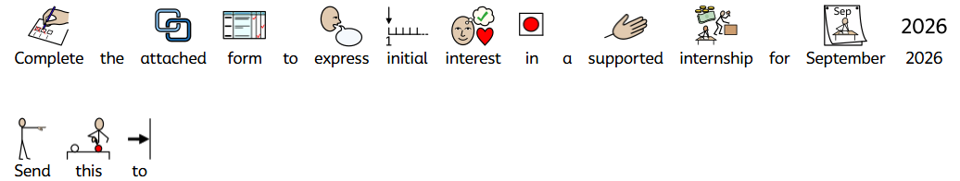

To apply for a Supported Internship please fill out this application form. To be considered applicants must be aged 16+ with an Education, Health and Care Plan.
Send this application form to SupportedInternships@bolton.gov.uk
Application Deadline: 2nd February 2026
Confirmed offers will be available by: 31st March 2026

Section A: The following information can be completed on behalf of the applicant.

Applicant Information:
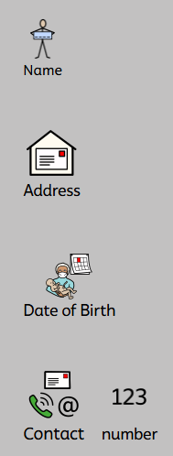
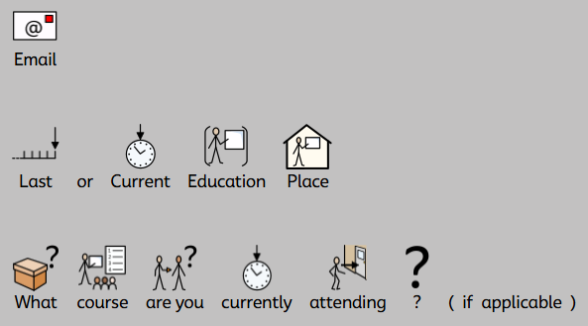
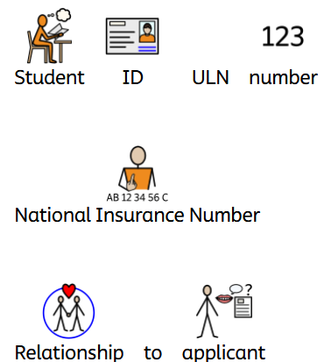

Emergency Contact Information:
I give consent for my application to be discussed with my emergency contact (please delete as appropriate) | 

Document Check List:
The follow documents will be required to gain a placement on a Supported Internship programme / Pre-Supported Internship programme. Please do not send copies of these documents at this time. These will be requested by the employers directly if placement is offered. Only one item from each row is required
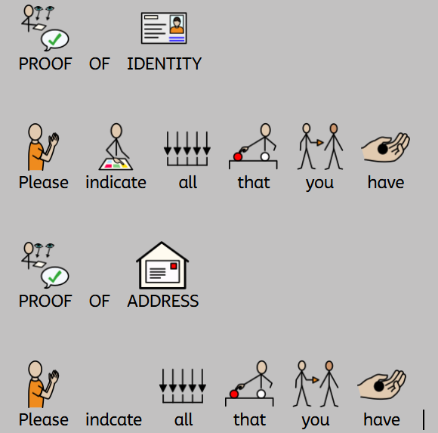 |  | 
 |  |  | 
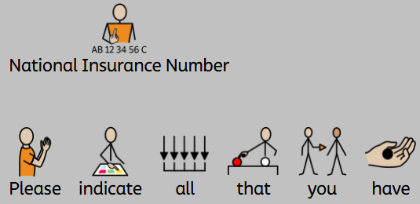 |  |  |  | 

Application Questions:
Q1. 


Q2. 
Consider your interests and hobbies, what are you good at, why would you like to join the supported internship? Include if you have had any work experience e.g. part time work, work placements or volunteering and if you have passed any qualifications.

?
Q3. Please tell us about any skills you feel you will need to develop further whilst on the Supported Internship programme
Q4. Please tell us about your aspirations for the future e.g. future career goals.
Q5. Please tell us about your Special Educational Needs including any important medical information e.g. hearing impairment, epilepsy, diabetes, other diagnoses such as ASD, ADHD, Dyslexia.
This information will help us identify what additional support needs you might have if your application is successful.
Available Programmes
Please number the programmes in order of interest (1 being first preference) and note any you are not interested in with an X.

Please note we can not guarantee your first choice programme.

Retail e.g. Supermarket Work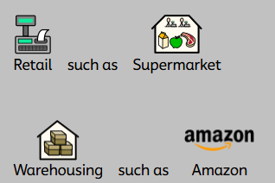

Warehousing e.g. Amazon

Catering e.g. Working in a resteraunt or pub
General Services e.g. Portering in a hospital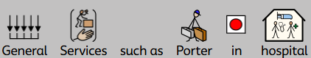

Administration e.g. Working in an office

Childcare such as working in a school or nursery
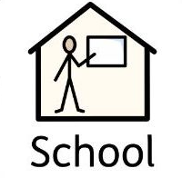
Pre Supported Internship Programme – A college based programme with work experience


Another field of work not listed above (Please outline below)


The Local Authority are always looking to expand the programme to include a wider range of employers. If you are interested in another area of employment not listed, please indicate below and we will inform you if an opportunity arises within your requested field.

If there is a particular work place or business you would be interested in please outline this below

Programme Expectations

This explains the expectations of the Supported Internship programme and sign at the bottom to indicate you have read and understood the content.

I will be required to attend an interview / assessment day. If I do not attend, I will not be offered a place on the programme. Being offered an interview is not a guarantee of a place on the programme.

I understand that while I may have a preference, I will be considered for programmes which may be appropriate to meet my needs.

I will be expected to attend independent travel training if I am not an independent traveller. I understand I can not apply for transport from the council transport team to get to my workplace however I may be entitled to a bus pass.

I will be expected to attend the workplace as agreed with the employer e.g. 9am-4pm Monday to Friday.

The programme begins in September and will end in June.

The aim of the programme is to be ready for paid employment

I will be expected to behave professionally in the work place at all times

I will be expected to engage in on the job training alongside classroom sessions at the workplace / host educator to develop my skills to prepare me for employment

My Education, Health and Care Plan will cease at the end of the programme as the internship is the final year of formal education

I am not guaranteed a job role / paid employment at the end of the programme

Please tick as appropriate

I have read and understood the above expectations and wish to apply for the Supported Internship / Pre-Supported Internship programme

I have further questions and request a callback from the team

I give consent for my information to be shared as part of the Supported Internship application

Name:
Signed:

Section C: Reference
Please fill in the following reference information. One reference is required from a current or most recent educator. If you are not currently in education a reference can be provided by Bolton’s Connexions Service, Careers Advisor, Work Coach, Personal Advisor or a Social Worker if you have one.
Please be aware that referees may be contacted to discuss their reference and to confirm its contents. A digital signature is acceptable for the form.
Please note that without this, your application cannot be considered.
Reference:
Name
Organisation and Role
 | Would you recommend the applicant for a Supported Internship, if so please state why.

To be signed by the referee:

Name:
Signed :
Date:

