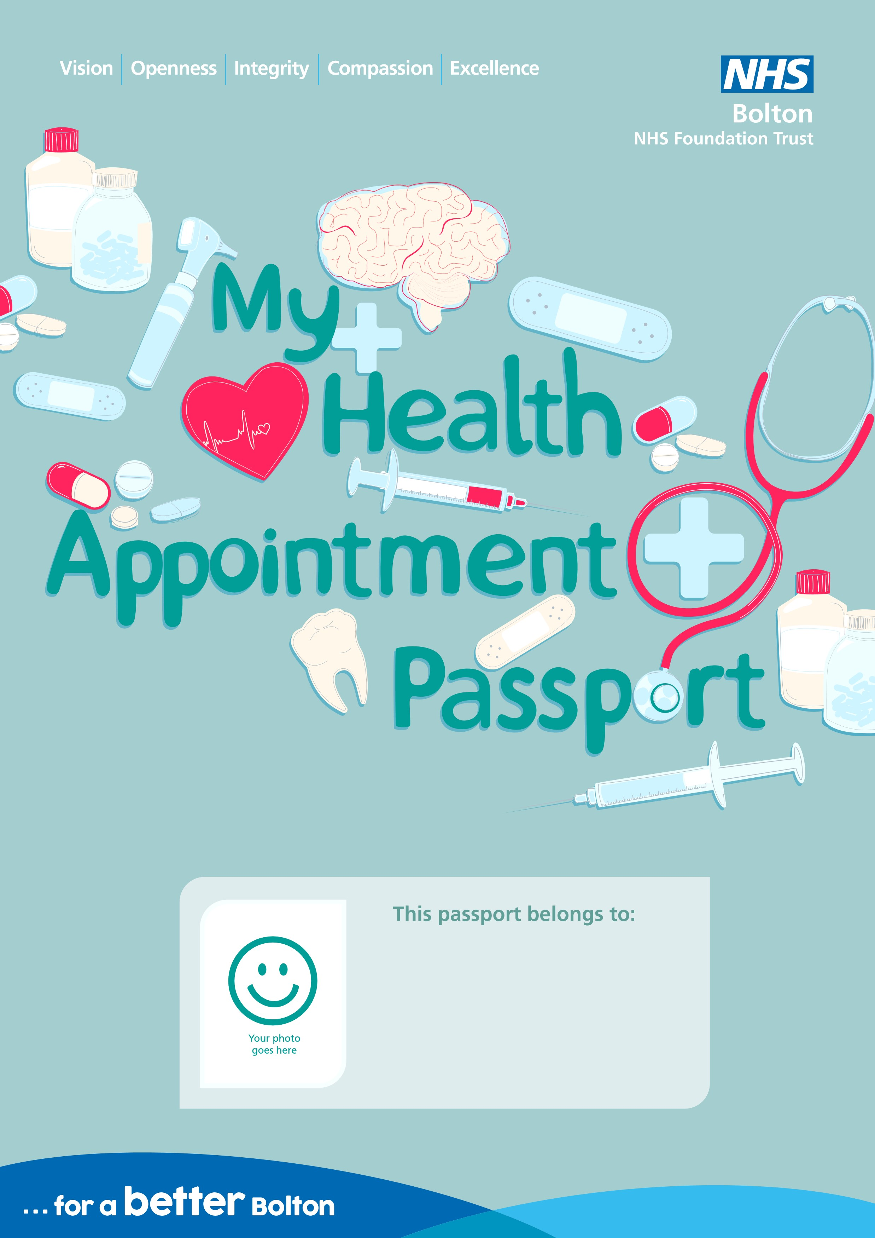

Please read, this passport contains important information about me.
This passport needs to be kept at the end of my bed, and a copy should be kept in my records.

This health appointment passport should be completed by you (the person this passport is about) and the people who know you best.
By filling in these details you are consenting (saying yes) to your information being shared with the staff who are caring for you.

Mental Capacity Act 2005
Please note the MCA applies from 16 years old.
Never assume I lack capacity,
if unsure undertake a capacity assessment using the
trust template, before making any decisions on my behalf.
If it has been assessed that I lack capacity to make a specific decision
about my
care or treatment a
formal, best interest decision
must be made and documented
on the trust template. This decision should be made with the people who know
me well.
The principles of the mental capacity act (2005) are applicable from age
16
years.
Name of the person who should be consulted and involved in the
capacity assessment and best interest decision process:
Relationship:
Contact phone number:
If treatment or physical intervention is needed has this been
agreed in the best interest and recorded accordingly?
(
Please select one
)
Yes
No
Date agreed:
If physical intervention (e.g. for a blood test to be taken) is required during my stay
in hospital my family and or carers need to consider how this can be implemented
and recorded.
All physical intervention plans should be shared with staff prior to or during the
admission process.
Staff will not engage in physical intervention unless the safety of the patient or

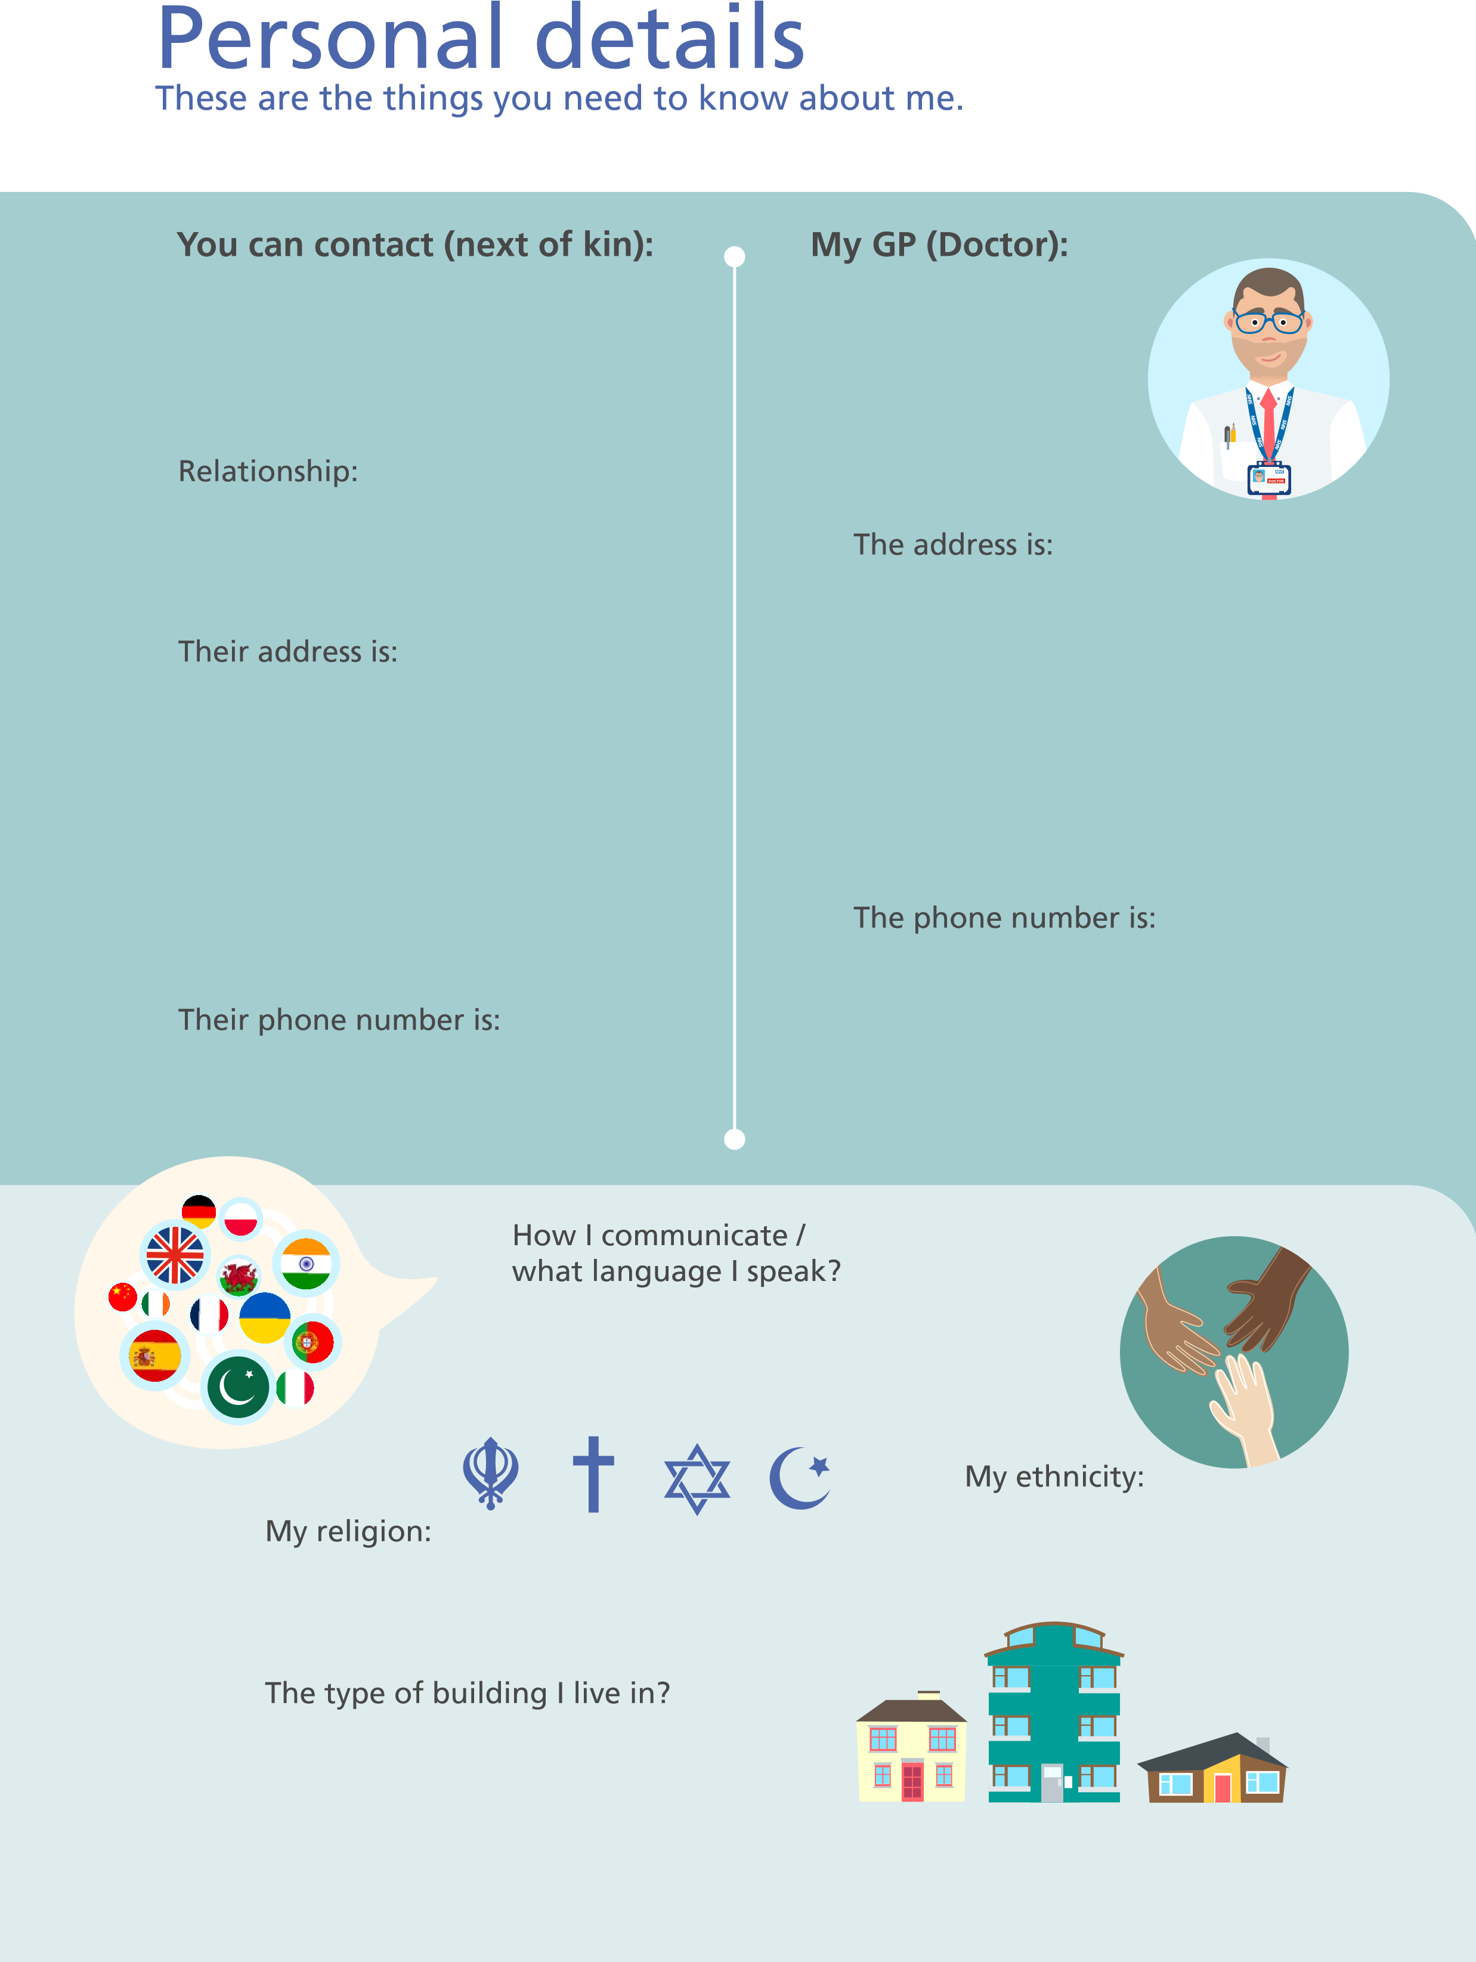

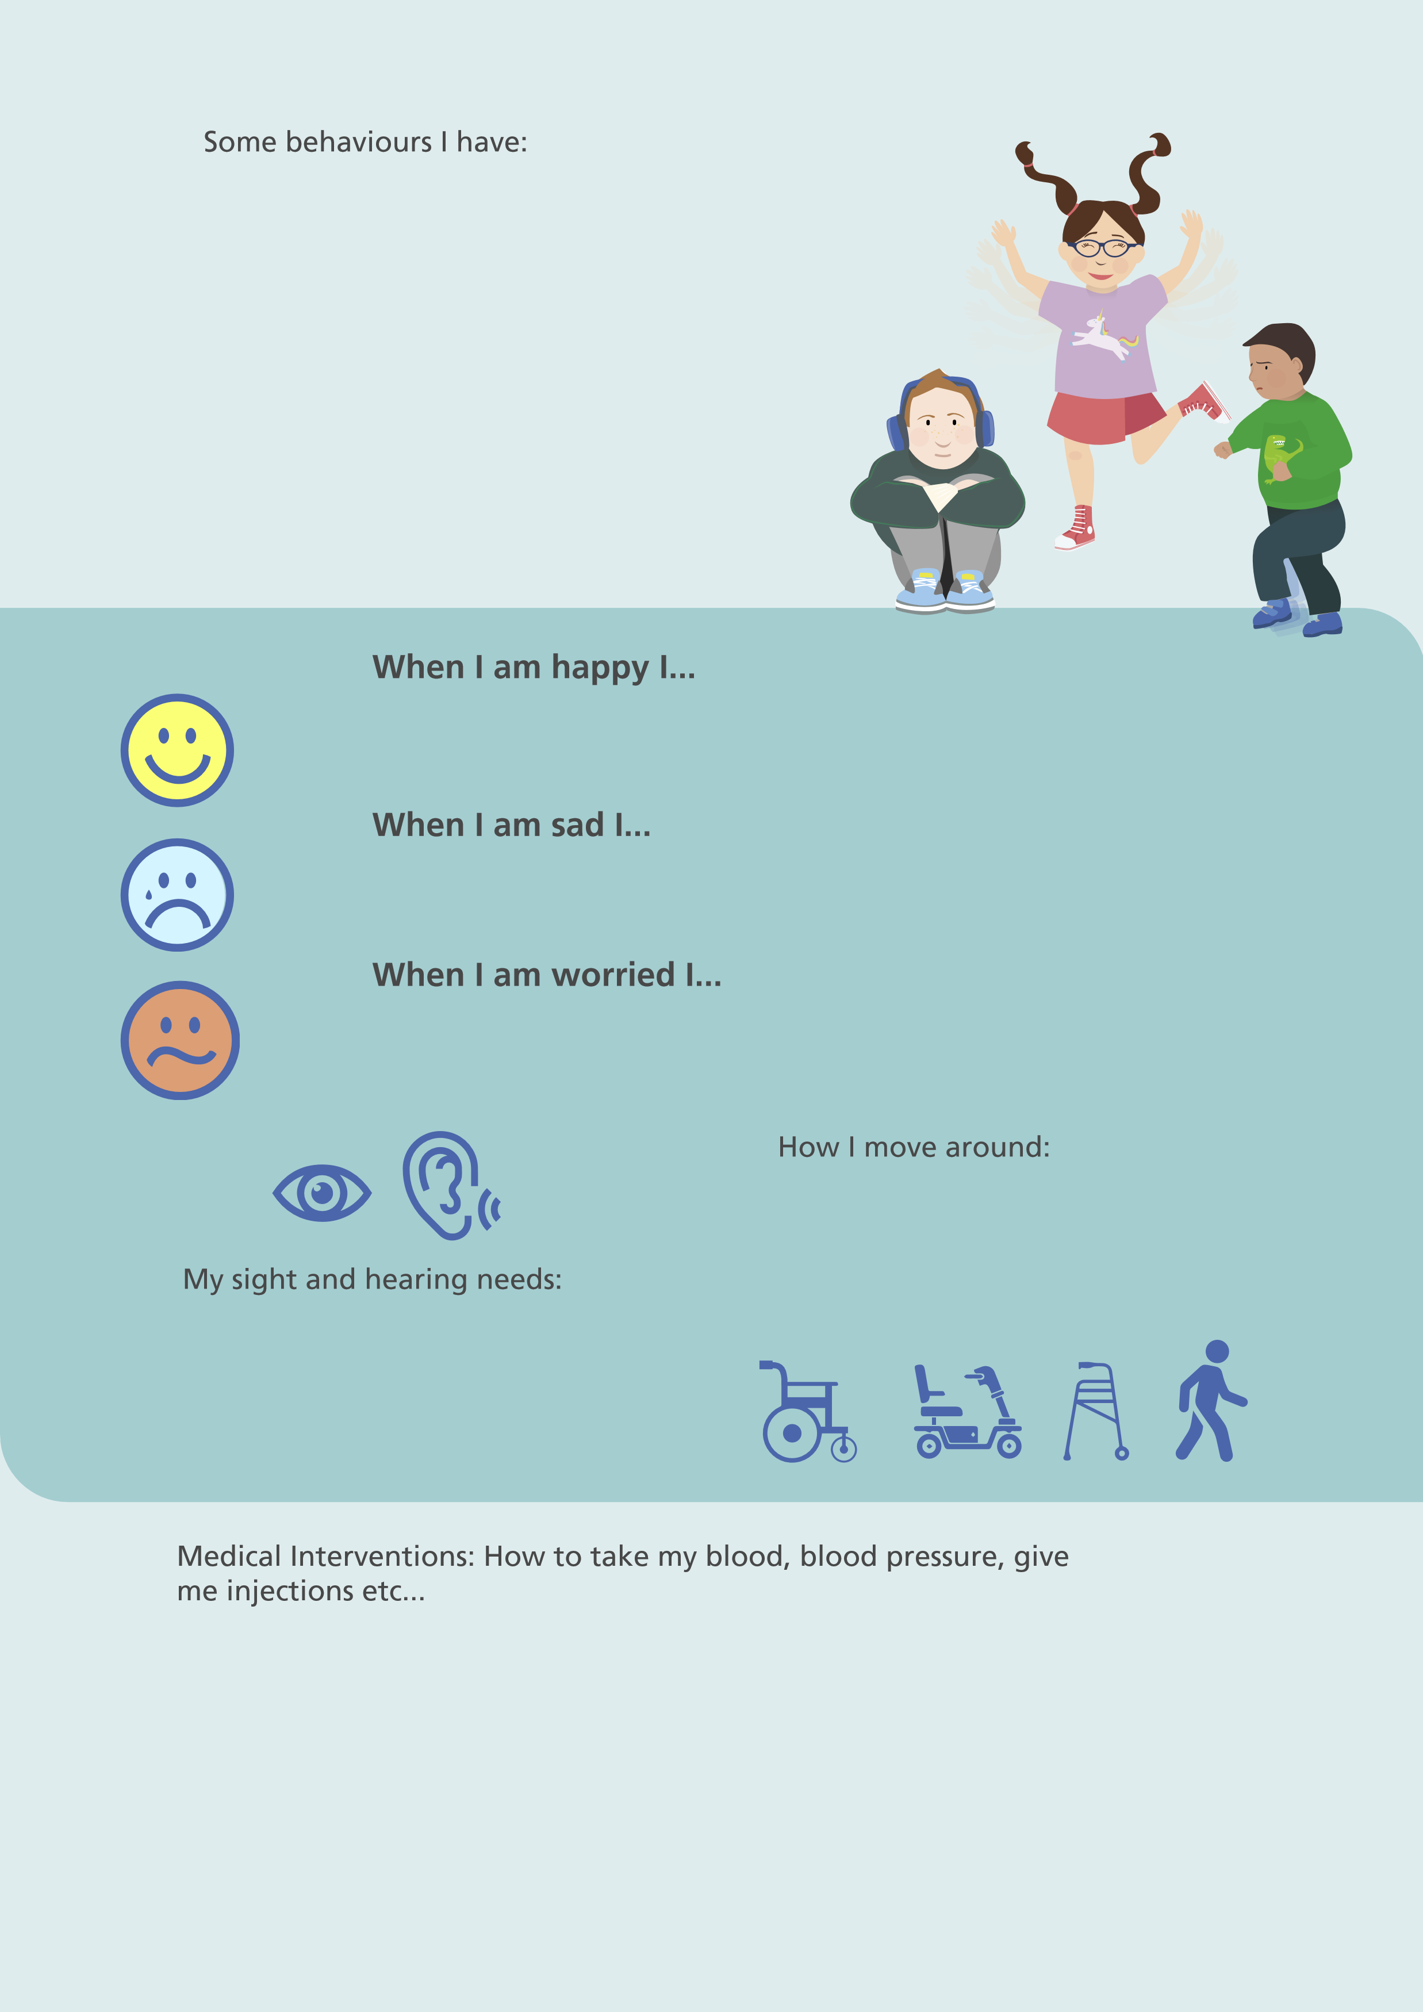

Things I like:
(
Please do these things
)
Things I don’t like:
(
Don’t do these things
)
My allergies:
The PRN (taken when needed)
medication I am taking:
The regular medication I am taking:
How I take my medicine:
How I show pain or discomfort:
Has a pain assessment
been considered?
yes
no
Any issues with my heart or any
breathing problems?
Skin conditions/ skin integrity
information:

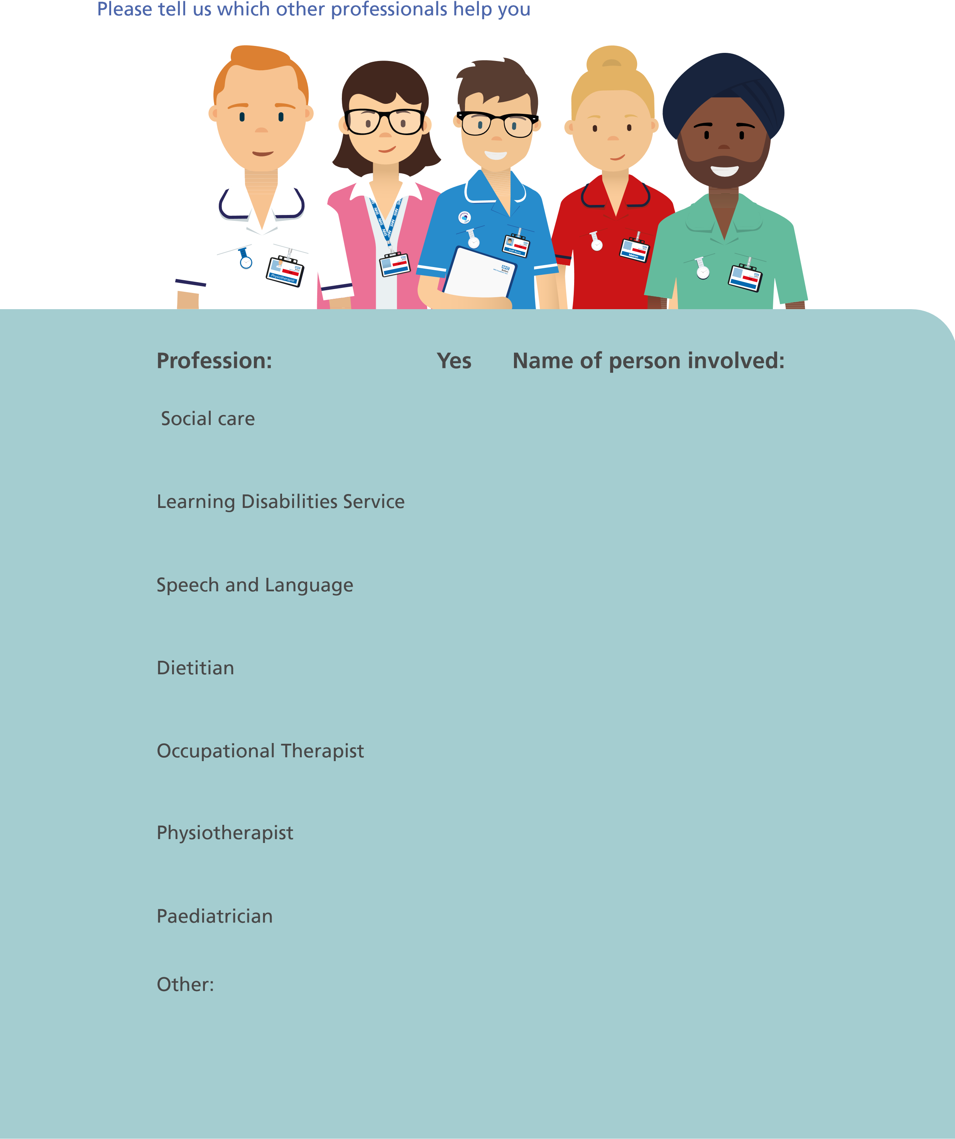
People involved in my care

Reasonable Adjustments

How can staff help you?
Keep loud noise to a minimum where possible
I need to be in a quieter area
Give me time to process information
Explain what is happening - without medical jargon
Help me with filling forms and reading information

Having someone with you

Other:
yes
no
List any sensory requirements you might need:
e.g. lighting, noises, strong smells, touch

Notes

Review date:
August 2022
Next review date:
August 2024

