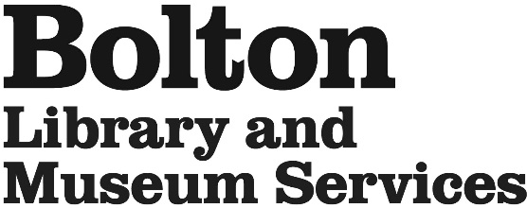
College/University Work Placement Application

This form is for work placements lasting more than 1 week from colleges & universities.
For 1 week secondary school work experience please apply on this link
Work Experience Application Form

Name: ________________________________________________

Email: ____________________________________________________________________

Telephone Number: ___________________________

College/Universty:____________________________________________________________

Date of birth: _______________ Dates of placement: _________________________

Please tick which venue you would like to work at. Tick no more than 2 venues. Ideally these should be close to your home or easy for you to get to.

Bolton Central Library and Museum |  | Aquarium |  | Smithills Hall
Blackrod Library |  | Breightmet Library |  | Bromley Cross Library
Farnworth Library |  | Harwood Library |  | High Street Library
Horwich Library |  | Little Lever Library |  | Westhoughton Library

* Please tell us why you would like to do your work experience with Bolton Library and Museum Services

We have a very high number of applications for work experience; please note that completing this form does not guarantee a placement.

Please return the application to your by email to blamsvolunteering@bolton.gov.uk

