MAYOR ST DEPOT HEALTH & SAFETY PLAN

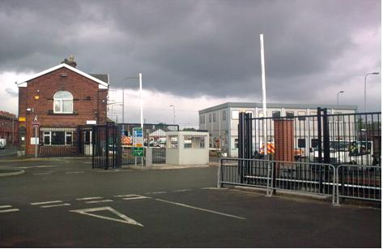
March 2026
Version 9

Contents
Introduction 1
Depot Occupants 1
Site Security / Access 1
Depot Visitors 2
Pedestrians 2
Signing in – Ellesmere House Visitors 2
Signing in – Contractors working in Mayor Street Depot 2
Vehicles 2
Site Layout 3
Depot Boundaries 3
Site Makeup 3
Depot Layout 4
Vehicles 4
Pedestrians 4
Depot Operating Hours 5
Communications 6
Depot Safety Rules 7
Safety Responsibilities and Non Compliance – Depot Rules 8
Inspections 9
Monthly Safety Inspectors 9
Monthly Depot Team Inspections 9
6 Monthly Depot Team accompanied by Union/Management 9
Ad-hoc Reporting 9
Accidents, Incidents and Near Misses 10
Waste Management 11
Scrap Metal 11
Cardboard 11
Sodium Lamps 11
Other Skips: -Plastic, Wood, Mixed Waste, Concrete Columns. 12
Tarmac & Rubble Bay 12
Sanitary & Medical Waste 12
General Municipal Waste 12
General Guidance 12
Emergency Evacuations 13
Material Storage 14
Spillages 14
Deliveries 15
Deliveries for Internal Stores / Stock 15
Deliveries for External Storage – Stock and non-Stock 15
Depot Hazards 16
Fuel Tank – H1 16
Gas Compound – H2 16
Sodium Lamp Containers – H3 16
Tarmac Hotbox – H4 16
Salt Barn and Hopper – H5 17
Sign shop Compressor – H6 17

Introduction

Bolton Council is required by law to ensure that the health and safety of its employees, contractors and members of the public are not put at risk because of the work it undertakes.

This document refers and adheres to existing Bolton Council Policies and explains how the Mayor Street Depot site is managed and maintained so that it is a safe environment to work in or visit.

The Depot is managed by.
Corporate Asset Management
3rd Floor, Town Hall
Victoria Square
BOLTON
BL1 1RU
01204 331234

All defects relating to Mayor Street depot are reported to Report a repair online

Depot Occupants

This is a large depot close to Bolton town centre that provides an operational base for several sections and services including:

- Depot & Stores Team
- Neighbourhood Services
- Highways – Street lighting – Drainage
- Social Needs Transport (SNT)
- Building Cleaning (storage facilities)
- Regulatory Services

Under the electronic Cotag system there are over 350 authorised employees with access rights to the site and over 100 vehicles based at the depot; these include vans, pick-ups, gritters, lorry mounted cranes, JCB’s and a minibus fleet (SNT).

Site Security / Access

The site security is controlled using:

- Electronic Cotag system on all vehicle and pedestrian points of access/egress
- Manual lifting of the vehicle barriers with the aid of an intercom system
- CCTV cameras with 24/7 recording
- Out of hours access (for non-Cotag holders) controlled by Security and Response
- Staff vehicles are not permitted within the depot at any time during operational working hours; however, motorcycles and cycles are permitted. (With the exception of private vehicles on standby who have taken a works vehicle home).

A small visitor’s carpark is situated outside the main gates. This may be utilised by staff for short stays (less than 2hour) Now managed by NCP, the depot has no control over the use of this car park. Any parking infringements are to be redirected to parking services.

Depot Visitors

Pedestrians

Pedestrian visitors to the depot may include members of the public, Bolton Council employees, contractors, and delivery personnel; they gain access to the depot by contacting their host who is responsible for them whilst on site.

Only authorised personnel or staff are authorised to access parts of the depot west of the main reception. The depot safety rules state that high visibility clothing must be worn beyond Ellesmere House reception.

Signing in – Ellesmere House Visitors

Any visitor remaining on site must be met by their host who must ensure that their guests are always escorted and signed in and out of Ellesmere House reception. The host is also responsible for ensuring that their guests comply fully with the rules of the depot and are made aware of the site housekeeping information. Please ensure you escort your guests out of the depot.

Signing in – Contractors working in Mayor Street Depot

Any contractors carrying out work within the depot must sign in at the depot office where a member of the depot team will ensure they are aware of the site rules, any hazards and when necessary, ensure they sign the asbestos register.

Vehicles

These will primarily be deliveries to the depot and will be dealt with by either a member of the depot team or a tenant host.

It is very important that any deliveries that are not stock, to inform the depot team on any such deliveries so that the depot team can ensure there is room, and they can be placed in a safe area.
mayorstreetdepot@bolton.gov.uk

Site Layout

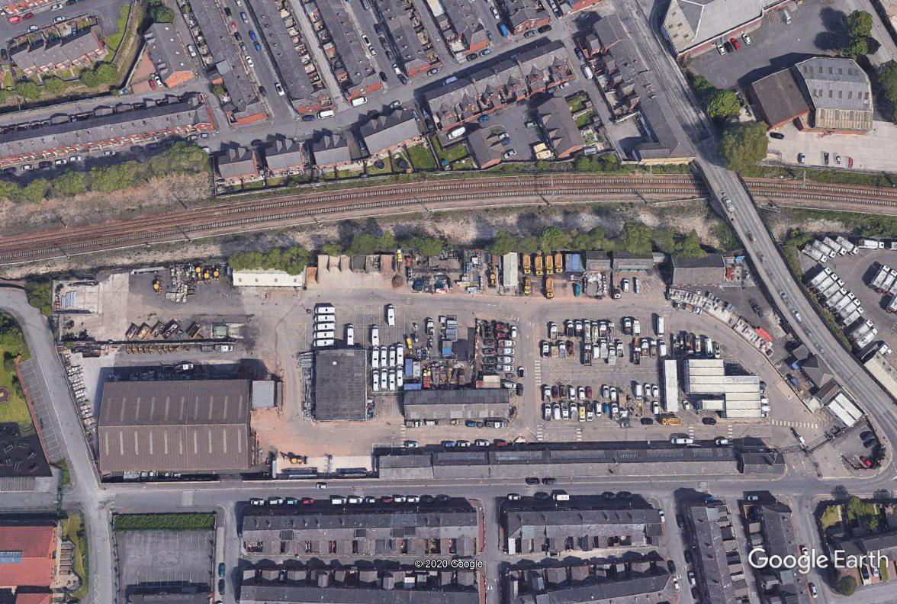

Depot Boundaries

- North – steel palisade fence adjacent to main railway line
- East – combination of brick wall and brick buildings adjacent to the B6202
- South – primarily the outside walls of depot buildings, the remainder being brick walls and disused gates adjacent to a residential area
- West – brick wall adjacent to a local school

Site Makeup

The buildings are used for:

- Storage
- Workshops – maintenance of plant, fabrication of signs, street lighting, parks equipment
- Garages
- Offices
- Welfare facilities

The open areas are used for:

- Outdoor storage
- Waste collection
- Vehicle parking

There is a small visitor’s car park adjacent to the main entrance gates to the depot, this car park falls outside the perimeter’s security.

Depot Layout

Depot access is gained by either vehicles or pedestrians on the southeast corner of the depot (as indicated on the plan below).

Once inside the depot vehicles and pedestrians must observe the rules applicable to their mode of entry.

Vehicles

Drivers must observe the following rules of the depot.

- Observe and adhere to the one-way system.
- Comply with the 5mph speed limit.
- Do not block any pedestrian walkways under any circumstances.
- Pedestrians have right of way over vehicles on pedestrian crossing points, please give way.
- Do not block fire exits.
- Do not park on fire assembly points.
- Use extreme caution and be extra vigilant when driving around the parts of the depot where there are no designated walkways.
- Please do not block the exit barriers / gate near the visitor’s car park, this messes with the gate timings and stops the automatic gate closing correctly.

Pedestrians

Pedestrian walkways have been provided around the majority of the depot and should be used by staff at all times. The walkways are checked regularly for obstructions and deterioration and are repaired when necessary. Pedestrians are requested to be vigilant and aware that the depot is an operational workplace with high traffic/plant movements.

The new layout of the depot has removed the walkways on the Northwest side of the depot and pedestrians have been routed to gain access to the west of the depot by using the walkway on the south side (adjacent to the main stores and workshops).

Pedestrians must observe the following rules of the depot:

- Use the pedestrian walkways and crossing points where available.
- Use extreme caution and be vigilant when accessing the parts of the depot where there are no designated walkways

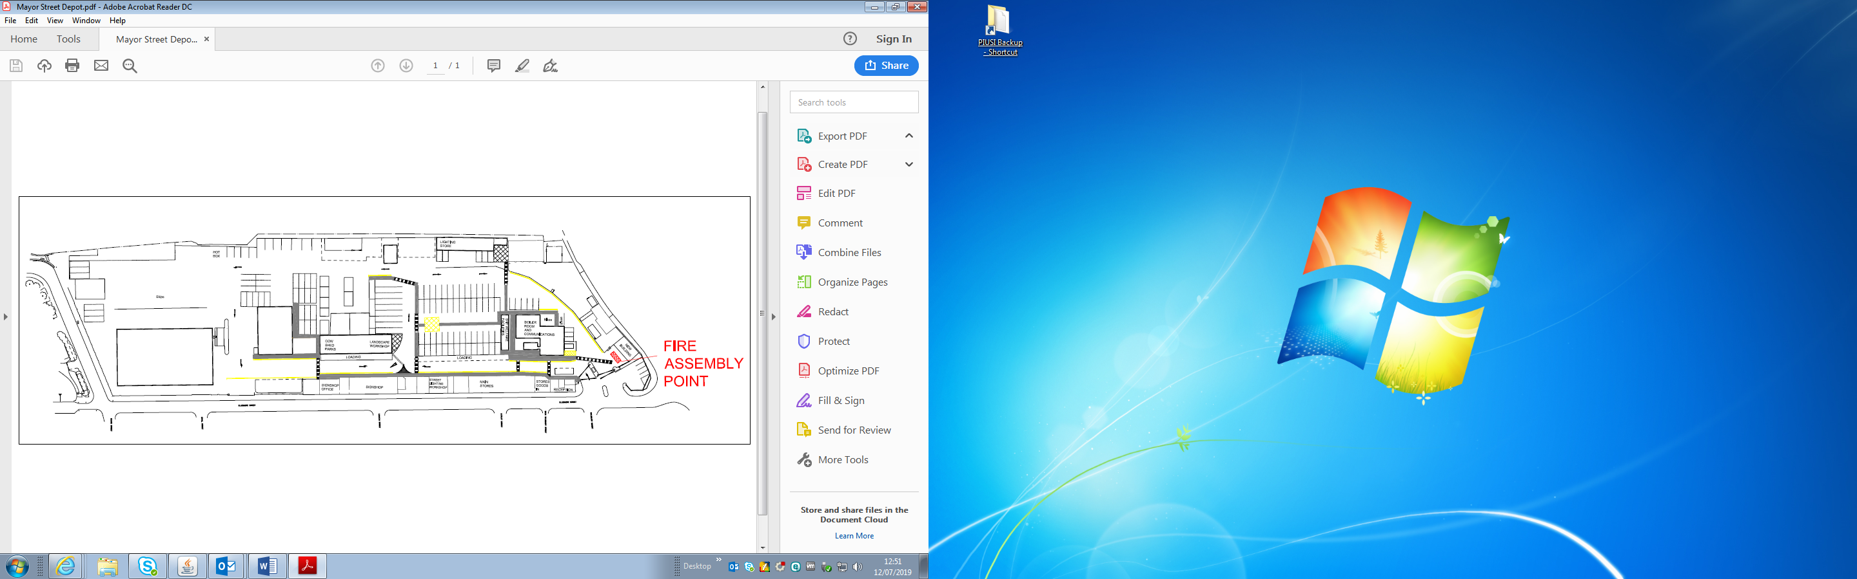
Depot Operating Hours

Mayor Street Depot’s normal operating hours are 07:00 – 15:30 hrs Monday to Thursday, 7:00 – 15:00 Fridays. During these hours the main gates to the depot will be open and access will be gained by both vehicles and pedestrians by a Cotag system.

Outside of the normal operating hours, the vehicle barriers will be in the raised position, the manual double gates and the electronic vehicle gate will be closed. The large pedestrian gate will also be bolted closed.

Entry/egress from the site by vehicle is through the “Out” side of the depot and entry/egress for pedestrians is through the turnstile both activated by cotag.

Communications

All Tenants of the depot are of equal standing, regardless of how much space they occupy and are requested to acknowledge and respect the needs of each other.

All Tenants are required to co-operate with the Depot Landlords (Corporate Asset Management), and other Tenants, so we ensure the depot is a safe working environment. All depot occupants are expected to share information about their operations within the depot, to ensure everyone has a general awareness regarding the risks of any activities. All employees have a general duty to ensure the Health, Safety and Welfare of themselves and others that may be affected by their activity.

The Depot Team will chair the 6 monthly meetings, collating actions and information and where necessary report to the Divisional Management Team (DMT). There will be no formal minutes, however, an action plan will be formulated and updated by the Depot Team; this is accessible to all parties.

In addition to the monthly meetings, any issues/defects that require immediate action should be reported via email to the Depot Inbox

mayorstreetdepot@bolton.gov.uk

Issues/defects will be collated and recorded on the Depot Defects page on SharePoint, using power apps to record the data, these defects will be sent on to the corporate helpdesk for actioning. These defects are available upon request by the depot team if required.

Depot Safety Rules

Please note that the depot safety rules apply at all times and are in operation 24/7; any breach of the rules will be dealt with regardless of the time/day it occurred.

 | Access to authorised personnel only or visitors accompanied by a member of staff
 | All visitors/contractors must sign in
 | 5mph speed limit
 | High visibility jacket must be worn beyond Ellesmere House reception
 | Where provided, dedicated walkways must be used
 | Obey the one way system
 | Park only in designated areas
 | No smoking/alcohol/drugs

Safety Responsibilities and Non Compliance – Depot Rules

A link to the Mayor Street Depot Health and Safety Plan has been emailed to all staff who have access to email, and hard copies are available on staff notice boards within the depot/store’s office.

The depot safety rules are on display at the entrance to Mayor Street Depot and appropriate signage is in place around the depot. All staff in the depot have received a personal copy of the depot safety rules either by e-mail or hard copy and have signed to say they have read and understand them.

It is the responsibility of all persons in the depot to comply with the rules and any infringement will be reported to the relevant line manager. Line managers are responsible for keeping a record of any non-compliance reports so that they can be discussed at the monthly depot (Landlord/Tenant) meetings.

Non-compliance of the Health and Safety rules will be managed in accordance with the Council’s Dismissal and Disciplinary Procedure.

All staff based at Mayor Street Depot must attend a site induction toolbox talk which will be held periodically. Any staff who have not attended a site induction session must make their line manager aware so that one can be arranged.

Inspections

Planned inspections will be carried out as detailed below and advice from external sources (e.g. Health and Safety Team) will be sought as and when necessary.

Monthly Safety Inspectors

Mayor Street Depot designated vehicle and pedestrian routes and the vehicle parking areas will be inspected by a Bolton Council Highways Inspector following the Council’s adopted Code of Practice (a copy of which can be found on Bolton Councils web site).

The inspections will be carried out on a monthly basis (last week of each month) and defects will be recorded on the proforma and map shown in Appendix B and C.

Monthly Depot Team Inspections

In addition to the above, a monthly inspection will be undertaken (carried out by a member of the Depot Team), detailing any obvious deteriorations or visible defects, using power apps / SharePoint as the data source.

6 Monthly Depot Team accompanied by Union/Management

Quarterly depot inspections will be undertaken, Unions and Tenant Managers will be encouraged to attend and provide input into the process.

Any issues raised will be dealt with by the Depot Team and reported to the Department Management Team for information or action. Any issues requiring immediate action will be dealt with and recorded.

Ad-hoc Reporting

Further to the above programmed inspections, all depot users and Union representatives are actively encouraged to report any concerns to directly to Corporate Property Services Report a repair online please copy in mayorstreetdepot@bolton.gov.uk for reference.

Accidents, Incidents and Near Misses

All accidents, incidents and near misses must be reported and dealt with in accordance with Bolton Councils Accident Reporting Guidance and Procedures. This document is maintained by the Councils Health and Safety Team and is available on the intranet.

All managers must inform a member of the Depot Team at the earliest opportunity of any accident/incident which has occurred within the depot. A copy of the accident report (which is also available on the Council’s intranet) must also be forwarded to the depot team as soon as it has been completed.

At the earliest opportunity, the Councils Health and Safety Team will be informed by the Depot Team of any accident/incident and appraise them of any action taken to date.

Waste Management

Mayor Street Depot has designated areas where a range of skips/containers/bays are set aside for waste management as shown on the plan below.

The following items can be dealt with:

- Scrap metal
- Plastic
- Wood
- Mixed waste
- Concrete lamp columns
- Cardboard
- Sodium lamps (hazardous waste)

Scrap Metal

The scrap metal skip is emptied by EMR Ltd and a report is emailed to the Depot Team who then instructs the Accounts Section to raise an Invoice to EMR for the value of scrap metal shown on the report.

Cardboard

This skip is emptied by VEOLIA

Sodium Lamps

Sodium lamps are classed as hazardous waste as they can catch fire when exposed to water. There are three plastic lidded containers available in the shuttered building adjacent to the LED storage to ensure the lamps are disposed of in a safe manner. These containers are checked on a regular basis by a member of the Depot Team who will arrange for the containers to be emptied when appropriate.

All staff that work with sodium lamps are responsible for the safe disposal of the lamps into the container and the cardboard into the separate bin.

An appropriate licensed contractor will collect and dispose of this waste and a waste transfer note is issued for each collection which is available for inspection in the depot office.

Other Skips: -Plastic, Wood, Mixed Waste, Concrete Columns.

The above skips are emptied on request by a contractor and all invoices are processed by the Depot Team.

Tarmac & Rubble Bay

Tarmac and rubble that has been excavated from various sites (in the main by Highways) is placed in this bay. At regular intervals a contractor will collect waste from this bay. The process is managed by the Depot Team and costs are recharged to the appropriate services. Mayor Street Depot is registered with the Environment Agency (renewed annually) with regard to holding this waste on a temporary basis.

Sanitary & Medical Waste

Facilities are provided in Ellesmere House for the safe disposal of sanitary and medical waste. An appropriate licensed contractor will collect and dispose of this waste and a waste transfer note is issued for each collection which is available for inspection in the depot office.

General Municipal Waste

Facilities are provided adjacent to Ellesmere House and at strategic points around the depot for disposal of general waste. Recycling is encouraged on the site and bins are available for plastics, paper and cardboard. These bins are emptied on a weekly basis by the Council.

General Guidance

All staff must ensure that waste is disposed of correctly and placed in the correct skip, bin or area. Waste areas must not be contaminated with incorrect waste as this leads to high tipping charges.

Waste disposal facilities in Mayor Street Depot must only be used to dispose of waste generated whilst carrying out work for Bolton Council. There are no facilities for any member of staff to dispose of personal items anywhere in the depot. Any person(s) found using the skips or discarding any personal items in the depot will be reported to their line manager which could lead to disciplinary action.

Emergency Evacuations

A fire assessment and evaluation of risk was carried out by Total Fire Group Ltd in November 2022 and all significant findings and recommendations have been carried out.

The Depot Team will carry out 1 fire drill per year, these will be unannounced to allow staff to be prepared for a real-life fire emergency.

Fire safety checks are carried out on a monthly basis by a member of the Depot Team and any issues are recorded and actioned. The fire alarms are also tested by Security and Response on a weekly basis (Thursday 10:00am). The open areas of the depot and the buildings are all equipped with appropriate fire extinguishers which are checked on a monthly basis by a member of the Depot Team.

On hearing the fire alarm all staff must evacuate and assemble at the fire assembly point.

The Depot Team will ensure that no further vehicles enter the depot until the all clear has been given and the Incident Controller will liaise with the fire wardens to ensure all personnel are accounted for.

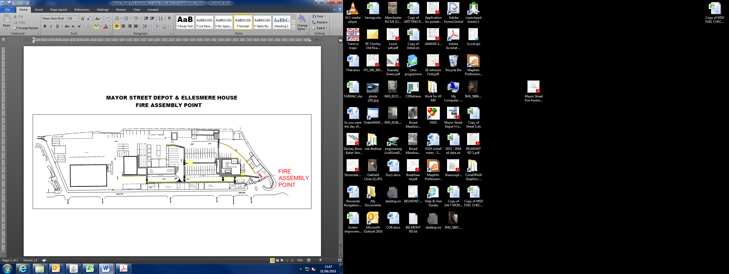

Material Storage

Space has been allocated around the depot for storage for all the depot tenants and building cleaning. The allocation is shown on the diagram below.

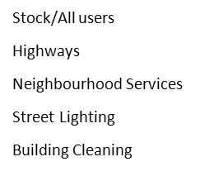

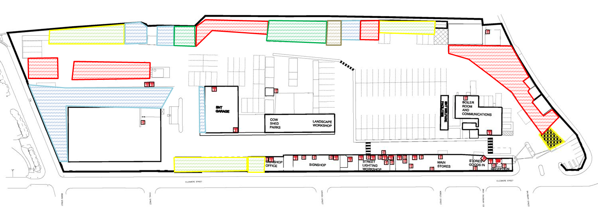

Tenants are requested to maintain a safe working area around any stored items and ensure the storage areas do not migrate outside of their designated space. The safe use of the storage areas are checked on the weekly inspection and any issues will be recorded and addressed with the appropriate Tenant.

Spillages

Spill kits are located at various points around the depot, as indicated on the diagram below and one is located in the depot team/plant vehicle for use remotely.

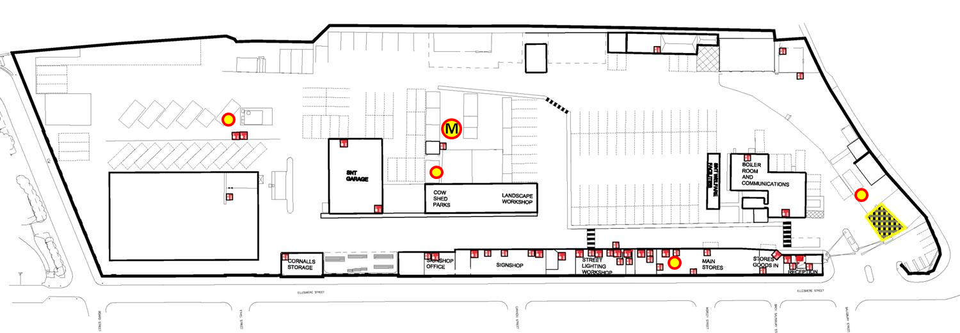

Deliveries

Deliveries fall into 3 main categories:

- Deliveries for internal stores /stock
- Deliveries for external storage - Stock
- Deliveries for external storage – Nonstock

Deliveries for Internal Stores / Stock

All deliveries will be accepted by a member of the Depot Team and will either be taken over the counter or through the store’s delivery bay door.

All delivery vehicles that enter the depot must park in the designated loading area (see drawing below) and the item(s) will be offloaded and conveyed safely to the delivery bay door via the designated walkway and crossing point.

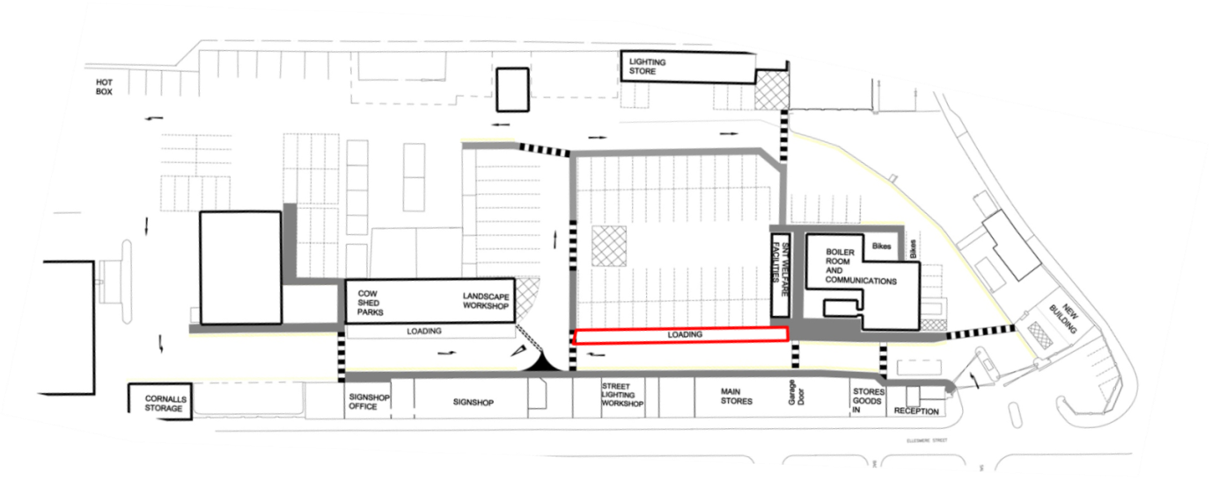

Deliveries for External Storage – Stock and non-Stock

All deliveries to Mayor Street Depot should be pre-arranged with the supplier and where not ordered by the depot team the person ordering must inform the depot team either by email to mayorstreetdepot@bolton.gov.uk or verbally.

The depot team will liaise with the tenant regarding offloading and storage of the items and where necessary request assistance with the task.

Depot Hazards

Several areas within the depot, by definition of use, are more hazardous; however, measures are in place to reduce/control the hazard.

See plan below for the locations.

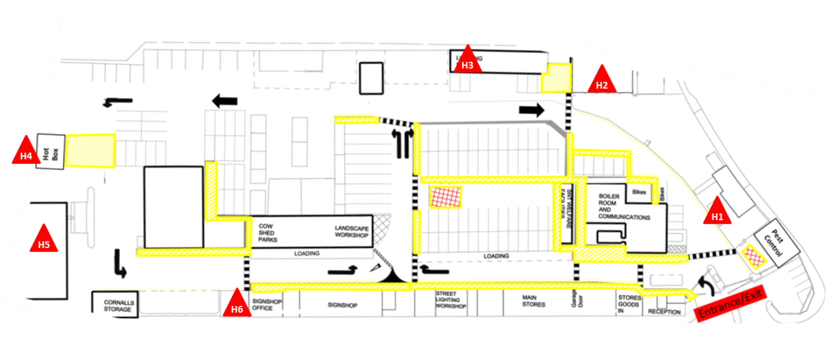

Fuel Tank – H1

The fuel tank has a capacity of 5,200 litres adjacent to which is an interceptor tank sufficient in size to take the full capacity should there be an incident, the tank is allow bunded for extra protection.

The tank and associated equipment is checked weekly by a member of the Depot Team when taking the gauge readings.

Gas Compound – H2

Both full and empty gas bottles are stored in the secure gas compound; the depot team hold the key for the compound and arrange for deliveries and collections.

Sodium Lamp Containers – H3

There are three plastic lidded containers available in the shuttered building, adjacent to the LED lighting store, to ensure the lamps are disposed of in a safe manner. These containers are checked on a regular basis by a member of the Depot Team and emptied when necessary.

Tarmac Hotbox – H4

Tarmac is delivered daily to the depot and is stored and issued from the hotbox by the JCB driver. The hotbox is checked and operated by members of the depot team on a monthly basis and all fuel refills are supervised by a member of the team and dealt with in accordance with the manufacturers’ guidelines.

Salt Barn – H5

The salt barn normally operates with circa 7,000 tonnes of loose product inside however this amount can vary according to the time of the year. Bury council share the stock of Salt, and operate their gritters out of the depot.

Sign shop Compressor – H6

The sign shop compressor has now been relocated to within the sign shop buildings, this is now under the control of the sign shop, in terms of keeping clear access.

Appendix A

Agenda
Mayor Street Depot
6 Monthly Users Meeting

Date
Attendees | Depot  SNT  Highways  Neighbourhood Services  Regulatory Services
Action Plan Updates
Issues
Information Communication
Ideas/suggestions
AOB

Mayor Street Depot - Surface Inspection Record

Name of inspector |  | Date Carried out

Item No. | Repair action to be taken | Task recorded
1
2
3
4
5
6
7
8
9
10
11
12
13
14
15

To be used in conjunction with Appendix C (Plan of Depot)

Mayor Street Depot - Monthly Inspection Action Record

Name |  | Date Carried out
Name |  | Date Carried out

Item No. | Repair action to be taken | Task recorded
1
2
3
4
5
6
7
8
9
10
11
12

To be used in conjunction with Appendix C (Plan of Depot) and the Check Sheet

Check | Yes | No | Task recorded
Depot External
Is integrity of perimeter wall/gates/fencing secure and safe?
Are there any loose slates or potential falling objects visible on the roofs?
Are the entrance gates and fencing secure?
Are gutters/downspouts free from for blockages/damage?
Are barriers/gates in good working order and the signage intact?
Is the external intercom/signage in good working order and signage intact?
Is the visitor’s car park free of detritus?
Check for any trips/spills near entrance (in icy conditions grit)?
Yard – Open Areas
Is the yard generally clean and tidy and free of clutter?
Are there visible signs of spills or other ‘slips, trips and falls ‘hazards?
Are all pedestrian routes free of obstruction?
Are all staircases secure and fitted with handrails which are in good working order?
Are all high voltage electrical cupboards secured?
Are all spill kits tamper free (check tamper tags)? – replenish any items used if not
Are all structural warning and information signs in place and clear
Are all fire signs/routes clear and free of obstruction?
Are all traffic management signs clear, unobstructed and undamaged?
Parking
Are parking bays being used appropriately? i.e. no long term storage on car park
Are there any vehicles/trailers parked in “No Parking” areas?
Storage
Are all hazardous substances and materials properly labelled?
Are all hazardous waste materials disposed of properly?
Are all hazardous substances and materials stored correctly?
Are materials and objects adequately stored or stacked to prevent them from falling and causing injury?
Are waste disposal facilities suitable with no overspills?
Are the open storage areas tidy and accessible?
Buildings
Are all fire escapes and routes to emergency exits free from obstruction?
Are windows secure/free from damage?
Welfare Facilities
Are the toilets clean, in good repair and with no spills on floor?
Have supplies been replenished?
Equipment
Have the monthly on the hot box being carried out?
Have the daily JCB checks being carried out?
Have the weekly fire checks being carried out?
Have the monthly legionella checks being carried out?
Have the daily inspections being carried out on the fuel pump?
Have the monthly fire doors / extinguisher checks being carried out?
Have the monthly emergency lighting checks being carried out?

Now inspected via PowerApps and logged in SharePoint

