# Creating User Accounts

Business Managers (**only**) with a Schools Extranet account, have the required access to create new accounts for other members of staff in school.

You must be logged into the Schools Extranet to do this.

Select **Setup** at the top of the page, then click **Create User** under Setup options on the right of the page.

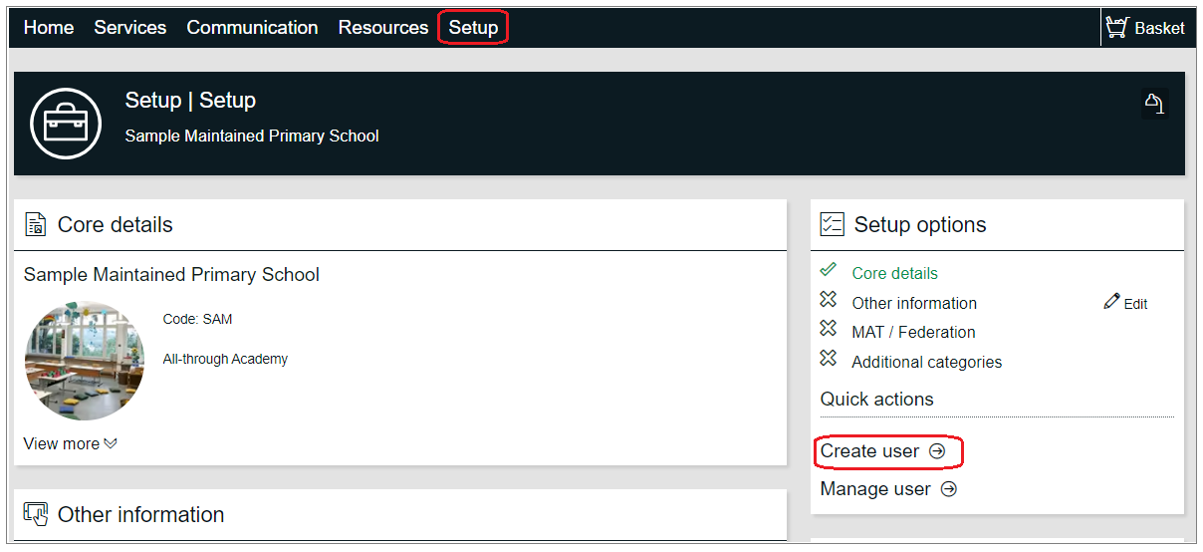

Complete the relevant fields on the page, only those marked with an Asterix * are mandatory.

|  |  |  |
| --- | --- | --- |
| **Section** | **Field** | **Notes** |
| General | Account Type | This should be set to **User** to allow the person being created to actively log on to the system. |
| Status | This should be set to **Live**.  Paused is to be used when staff leave the organisation. |
| Email | Please use a valid work email address.  **Do not use** generic email addresses such as admin@ or head@ etc. Likewise, domains such as @yahoo.co.uk, @gmail.com are not allowed. |
| Login Details | Required Password | The creator needs to enter a password, then ‘required password’ should be set to **Change** so that the account holder is prompted to change their password after their first log on. |
| Personal Details | Name | Enter name of the staff member that needs access. |
| Job Title | Enter their job title |
| Company | Enter the name of the school |
| Telephone | Enter telephone number. You can use main switchboard number. |
| Other Details |  | These are **not required** so no need to record dob or ethnicity |
| Roles | Role | Select the most appropriate role. **Only select one role**.  Headteacher, deputy head and business manager roles can do the following additional functions in the system:   * Record school closures * Manage users |
| Access Rights | Customer Access | Click ‘Add new access right’ |
|  |  |  |

**Access Rights:** Select the most appropriate group based on the users role.

Once all the details are completed click **Save**

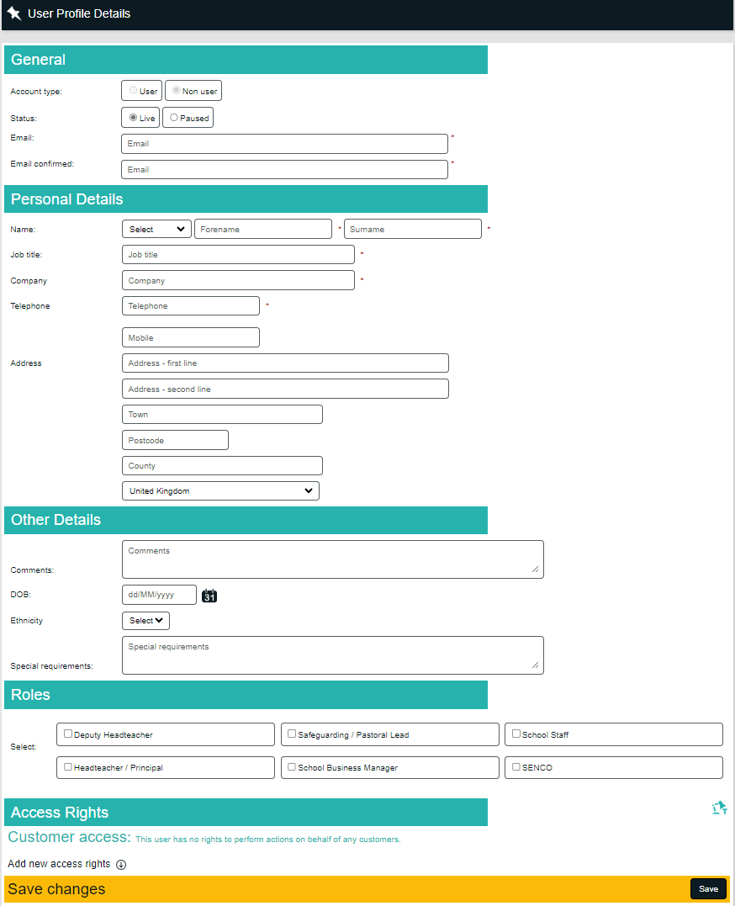

# Managing User Accounts

If a member of staff leaves your school and/or no longer requires access to the Schools Extranet, it is the schools responsibility to revoke this access, this is done by ‘Pausing’ the users account.

Headteachers, Deputy Head and Business Managers with a Schools Extranet account, have the required access to ‘Pause’ user accounts for other members of staff in school.

You must be logged into the Schools Extranet to do this.

Select **Setup** at the top of the page, then click **Manage User** under Setup options on the right of the page.

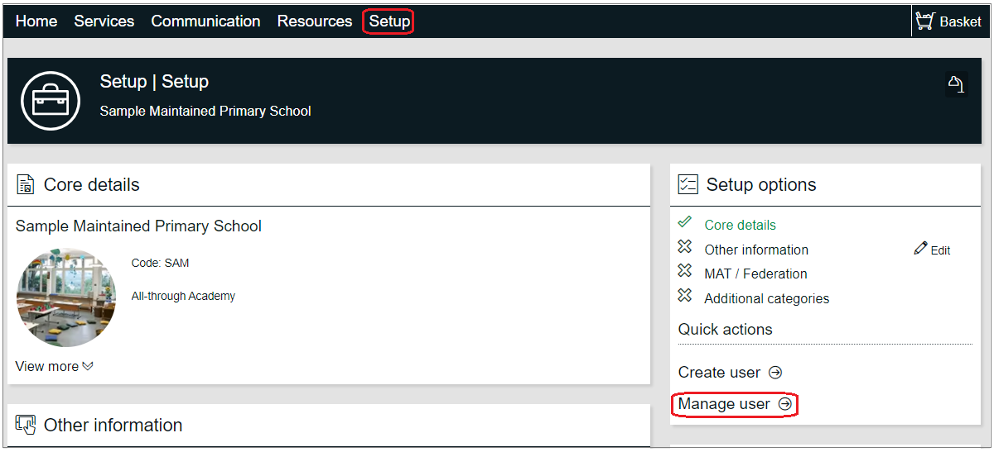

This will display all users for your school, click **Edit** next to the name of the users you want to ‘Pause’.

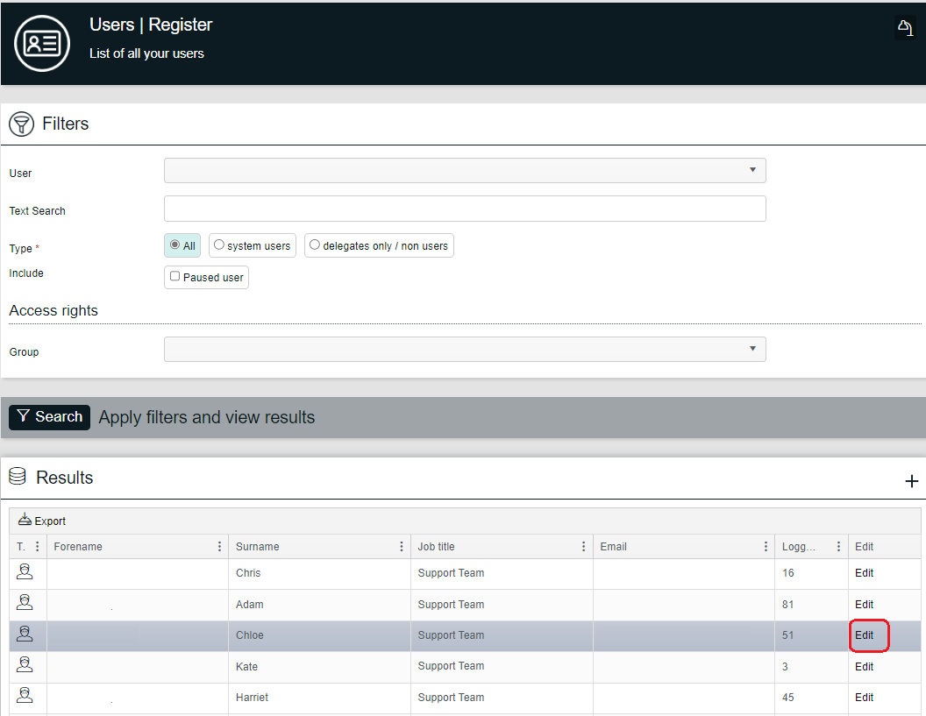

Select **Account and Contact Details** on the user profile page

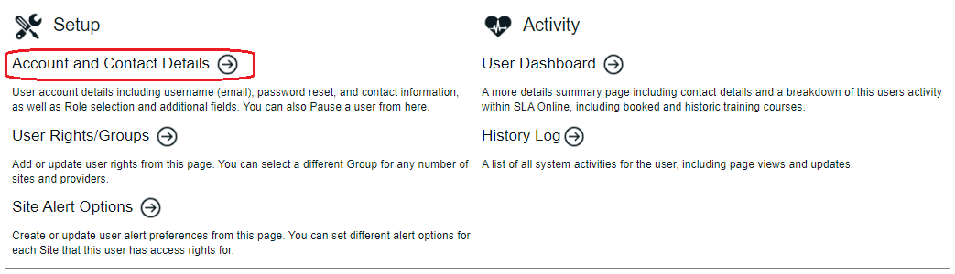

Change the **Status** to Paused and record a reason.

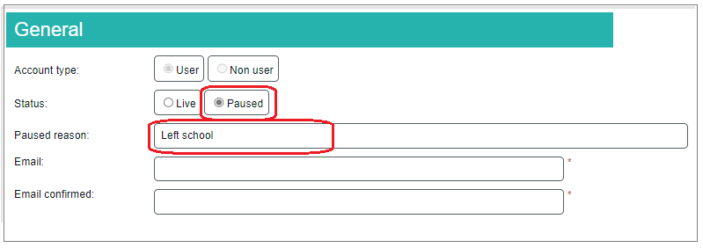

Change the **Access Right,** byupdating the Access **Group** to ‘School – Leavers Group’.

Click **Save** to commit the changes.

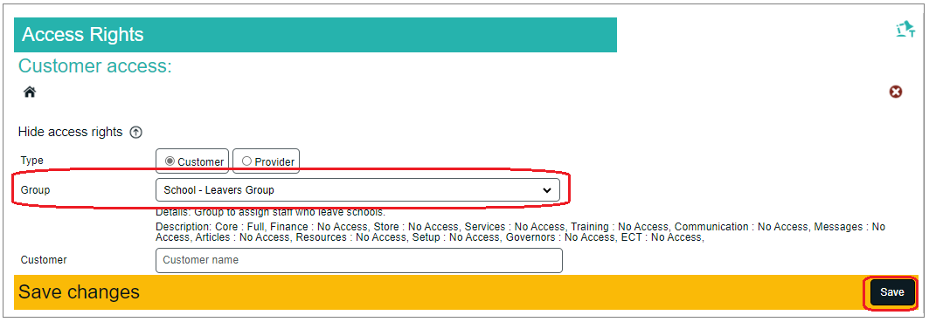

# Change of details

If a staff member changes name, email address or role within the school then this can by updated by selecting **Setup** at the top of the page, then click **Manage User** under Setup options on the right of the page.



This will display all users for your school, click **Edit** next to the name of the users you want to change.



On the screen below choose the appropriate option below:

