# Two Rooms at Smithills Hall

A room with a fireplace and wood floors in Smithills Hall

A kitchen in Smithills Hall
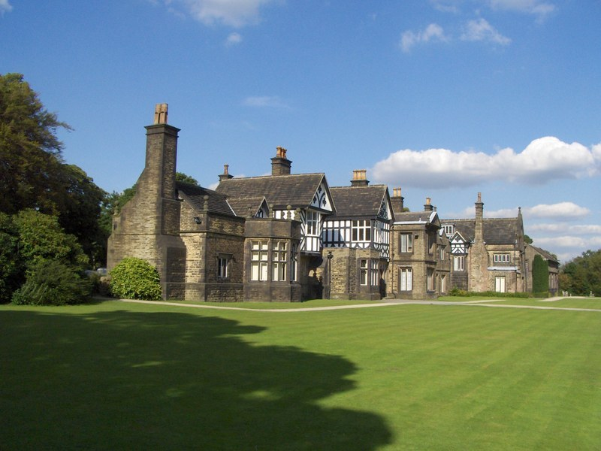

## Description:

Available to let at the Grade I listed, Smithills Hall, are two rooms suitable for office use, formerly used as a photography studio.

Smithills Hall is owned by Bolton Metropolitan Borough Council and maintained by friends of Smithills Hall. It is open to the public with a museum and Café.

Contact [boltonestates@robertson.co.uk](mailto:boltonestates@robertson.co.uk) for more information.

## Rent:

£2,880 per annum.

## Size:

Main room: 14.9ft x 14.2ft (211.58 sq.ft)

Kitchen: 6.7ft x 8.7ft (58.29 sq.ft)

Total: 269.87 sq.ft

## Location:

Smithills Hall, Smithills Dean Road, Bolton, BL1 7NP.