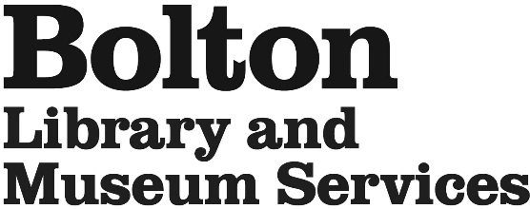
Work Experience Application

Name: ___________________________________________________________________

Email: ___________________________________________________________________

Telephone Number:________________________________________________________

School:___________________________________________________________________

Date of birth:_________________ Dates of placement:_____________________

Please tick which venue you would like to work at. Tick no more than 2 venues. Ideally these should be close to your home or easy for you to get to.

Bolton Central Library and Museum |  | Blackrod Library |  | Breightmet Library
Bromley Cross Library |  | Farnworth Library |  | Harwood Library
High Street Library |  | Horwich Library |  | Little Lever Library
Westhoughton Library |  | Smithills Hall |  | Hall ith wood Museum
School Library Services & Stock Services |  | Aquarium

* Please tell us why you would like to do your work experience with Bolton Library and Museum Services

We have a very high number of applications for work experience; please note that completing this form does not guarantee a placement.

Please return the application to your local library or by post to BLAMS Volunteering, Work Experience, Bolton Library & Museum, Le Mans Crescent, Bolton BL1 1SE, or by email to blamsvolunteering@bolton.gov.uk

