Personal Education Plan (PEP) Handbook

September 2021

Email: virtual.school@bolton.gov.uk
Website: www.bolton.gov.uk/children-care/vitual-schools

Personal education plans

All looked after children must have a Care Plan, of which the PEP is an integral part. The PEP (pre-school to age 18) should be initiated as part of the Care Plan. It is an evolving record of what needs to happen for looked after children to enable them to make at least expected progress and fulfil their potential. The PEP is a statutory document and is the join responsibility of the Social Worker and Designated Teacher.
The Designated Teacher should take a lead with chairing the PEP meeting and completing the termly PEP document.
Information and Guidance
- The PEP is a statutory document and is the joint responsibility of the Social Worker and Designated Teacher. The Designated Teacher should take a lead with chairing the PEP meeting and completing the termly PEP document.

- The PEP should be completed within 10 working days of a child being taken into care and should be reviewed on a termly basis. A review should also be initiated when a school or care placement changes.

- Statutory guidance describes the PEP as a ‘living document’ and the key part of the document is the targets section which should be reviewed by everyone including the child or young person on a regular basis to ensure they are on track.

- Apart from when a child/young person is new into care the previous PEP should be a starting point for each meeting with any updates made to Part 1 in advance. The meeting itself should focus on Part 2 – reviewing targets set, recording progress made towards identified outcomes and setting new targets if appropriate.
PEP deadline dates
- Autumn Term – Friday 17th December 2021
- Spring Term – Friday 25th March 2022
- Summer Term – Friday 15th July 2022

Process

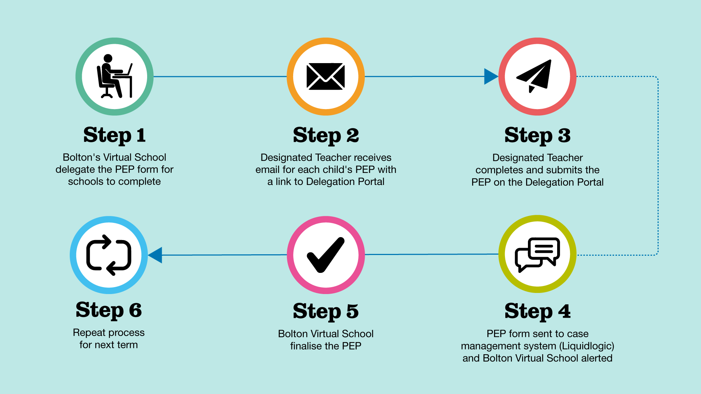
- The Virtual School team are responsible for the delegation of all PEP documents from Early Years to Post-16.
- Autumn PEPs will be delegated during the last week of the Summer holidays
- Spring PEPs, the first week back after Christmas
- Summer PEPs, the last week of the Easter holiday.
- Part 1 will be delegated to the allocated social worker – the majority of information will be pulled through Liquid Logic and it will need to be checked and updated by the social worker if there are any changes.
- All other parts will be sent to the Designated Teacher to complete prior and following the PEP meeting.
- Once the Virtual School have received the completed PEP document, it will be finalised and uploaded onto Liquid Logic.

The Virtual School are unable to attend all PEP meetings and the criteria for Virtual School involvement in PEPs is as follows:
- New case on Virtual School roll
- School placement move
- Pupils educated out of borough
- ‘Red’ rated case (concerns raised at Education Referral meeting (ERM) or due to poor attendance/engagement/school rated less than ‘good’ by Ofsted.
- Need for independent chair due to professional disagreement e.g., Pupil Premium spend to appropriately support need
- Key year groups such as Year 11 or Year 6.

PEP Process and role of Virtual School (word document format)

smart targets

STEP–BY–STEP GUIDE TO DEFINING MEASURABLE ‘PLANNED OUTCOMES’

All targets should be driven by the outcome we want to achieve. Targets set should be SMART (specific, measurable, achievable, relevant and time-bound) and should present a balance of academic and personal development targets. Targets should not only address areas of difficulty and should also aim to develop areas of strength.

• Step 1: Identify the unmet needs: Before anything else, it’s necessary to be clear about the child’s unmet developmental and educational needs as well as their developing areas of strength.

• Step 2: Identify the services/support: Once the child’s needs are clearly identified we can then look at areas of appropriate support or referral to additional services. the services, support, actions

• Step 3: Ask a few questions about each identified need/risk factor:
- If this need was being met sufficiently (or if this risk was sufficiently reduced), how would I know?
- What would I see/measure/count etc. that would tell me?
- What would be tangibly different about or for the child?
- How would I determine that the child’s development / wellbeing / care / safety has really improved?
- Have the services provided or the actions taken had any impact?

Example
My need: I need to achieve a 4 in GCSE maths and English to go to college
My problem: I am currently achieving a 3 within GCSE maths and English
What action is required? Additional maths and English intervention to boost grade
By when? Additional support throughout the Spring and Summer Term

‘Billy has improved from a GCSE 3 in mathematics to at least a GCSE level 4 by the end of the Summer Term to enable him to achieve his target grade.

example targets
Cognition and Learning
- XXXX has developed his/her knowledge of literacy skills including letter names and decoding text, so he/she is able to make progress in line with the school’s model of assessment by the end of the Autumn/Spring/Summer term.

- XXXX has developed his/her knowledge of numeracy skills, including his/her counting knowledge and his/her knowledge of shapes, space and measures, so he/she is able to make progress in line with the school’s model of assessment by the end of the Autumn/Spring/Summer term.

- XXXX has developed his/her understanding of instructions, so he/she is able to understand tasks with more independence on a daily basis by the end of the academic year.

- XXXX has developed his/herconcentration and attention skills so he/she is able to remain on tasks for at least 15 minutes by the end of the term.

- XXXX is able to complete written tasks independently without prompting to use punctuation and to be able to reach a target of XXXX by the end of the academic year.

- XXXX is able to retain and use mathematical tools and increase his/her knowledge of problem solving so he/she will be able to reach a target of XXXX by the end of the academic year.

- XXXX is able to consolidate his/her numerical and mathematical capability so that he/she can extend his/her understanding of the number system and place value to include decimals, fractions, powers and roots by the end of the Autumn/Spring/Summer term.

- XXXX is able to complete written tasks using appropriate punctuation so that he/she can reach a target of XXXX by the end of the academic year.

- XXXX is able to increase his/her knowledge of spelling patterns, word families, roots of words and derivations and will be able to correctly write and spell 300 high frequently words by the end of the academic year.

- XXXX is able to follow instructions and tasks for a minimum of 5 minutes on a daily basis throughout the Autumn/Spring/Summer term.

- XXXX has developed his/her processing speed and memory skills so he/she is able to carry out tasks with limited adult support, on a daily basis throughout the Autumn/Spring/Summer term.

Social Emotional and Mental Health

- XXXX has developed his/her ability to behave in an appropriate manner, including his/her ability to decode a range of social situations and understand the effect his/her behaviour has on this, so that he/she can apply strategies to help to make good choices with increasing independence on a daily basis by the end of the academic year.

- XXXX is able to understand social situations and be able to interact confidently with children and adults; this will enable him/her to build and sustain positive relationships both at school and home throughout the academic year.

- XXXX has developed an understanding of his/her own emotions so that he/she is able to identify basic emotions in others and him/herself and be able to express these in an appropriate way on a daily basis, reducing his/his SDQ score from XX to below XX by the end of the Autumn/Spring/Summer term.

- XXXX has developed his/her communication skills in various contexts such as group discussions, class discussions, during both break times and social activities so that he/she can fully participate in the full learning environment of the school on a daily basis.

- XXXX is able to increase his/her ability to accept changes in his/her daily routine, by using strategies taught, at home and school on a daily basis.

- XXXX has increased his/her awareness of others around him/his through interaction so he/she is able to tolerate a shared activity with one other for short periods at least 3 times a week throughout the Autumn/Spring/Summer term.

- XXXX has begun to increase his/her understanding of emotions so he/he is able to recognise when he/she is happy or angry by the end of the Autumn/Spring/Summer term.

- XXXX has developed his/her social skills to a level where he/she is beginning to contribute and take turns in conversations with an adult and his/her peers at least 3 times a week by the end of the Autumn/Spring/Summer term.

- XXXX is able to understand social situations and be able to interact confidently with his/her peers and adults; so that he/she can identify at least 3 characteristics of a healthy relationship and 3 characteristics of an unhealthy relationship by the end of the Autumn/Spring/Summer term.

- XXXX is able to use strategies that are in place to begin to overcome his/her anxieties during transition times of the day by the end of the Autumn/Spring/Summer term.

Speech/ Language and Communication
- XXXX is able to produce all speech sounds and be understood during conversations at school and at home on a daily basis.

- XXXX is able to increase his/her understanding of language, so he/she is able to understand text and be able to complete tasks with some independence by the end of the Autumn/Spring/Summer term.

- XXXX will improve his/her verbal reasoning and inference skills so that he/she can consistently explain what is implied (suggested meaning) rather than what is explicit (stated/obvious meaning) by the end of the Autumn/Spring/Summer term.

- XXXX has developed communication skills so he/she is able to express his/her wants and needs to those around him at a level he/she understands e.g. use of PEC’s, and to do this on a daily basis by the end of the Autumn/Spring/Summer term.

- XXXX has increased his/her ability to make requests using PEC’s throughout the day so he/she is able communicate his/his/his wants and needs on a daily basis by the end of the Autumn/Spring/Summer term..

- XXXX has developed his/her understanding of spoken language including his/her ability to follow instructions of increasing complexity so that he/she can complete tasks more independently by the end of the Autumn/Spring/Summer term.

Sensory/Physical
- XXXX has developed functional and fine motor skills so he/she is able to participate in physical activities and is able to move safely around school by the end of the Autumn/Spring/Summer term.

- XXXX has developed fine motor skills so he/she is able to independently take part in all aspects to the curriculum on a daily basis by the end of the Autumn/Spring/Summer term..

- XXXX has continued to develop his/her mobility to facilitate independent movement as appropriate to his/her development by the end of the Autumn/Spring/Summer term.

- XXXX has developed his/her fine motor ability so that he/she can produce letters and shapes clearly and produce a greater quantity of written work on a daily basis by the end of the Autumn/Spring/Summer term.
Independence and Self Help
- XXXX has started to develop independence skills so he/she is able to contribute to his/her own personal care needs as appropriate to his/her ability on a daily basis by the end of the Autumn/Spring/Summer term.

- XXXX is able to concentrate on an activity\task for an increasing about of time, leading up to a minimum of 10 minutes, at least once on a daily basis by the end of the Autumn/Spring/Summer term.

- XXXX has developed an awareness of his/her personal care needs so that with adult support XXXX can contribute towards his/her care needs as appropriate to his/her development over the academic year.

Strength and Difficulties Questionnaires (SDQs)

From September 2021 the Virtual School will be including Teacher SDQ into the termly PEP document. The Designated Teacher will be expected to update, track and monitor the termly SDQ score. A score of 17 or above suggests that the pupil may have emotional wellbeing needs which should be addressed within the Target Setting section.

We have designed an SDQ Excel calculator to help complete and score the SDQ, please contact the Virtual School team if you require a copy.

The SDQ is a behavioural screening questionnaire. The SDQ consists of three questionnaires that are filled out: one by the teacher, one by the student (dependent on age) and one by the parents/carers – they have the same questions in them, just asked in slightly different ways. The focus of this document is on the Teacher SDQ only. Each questionnaire consists of 25 questions assessing the following areas: emotional symptoms; conduct problems; hyperactivity; peer relationship problems; kind and helpful behaviour.

Why does the Virtual School collect this information?

Government guidance, 'Promoting the Education of Looked-After Children and Previously-Looked After Children' (Feb 2018) outlines that the Virtual School Headteacher should work with Designated Teachers to ensure that schools are able to identify signs of potential mental health issues and know how to access further assessment and support where necessary.

This is in line with Government advice for Designated Teachers (see Paragraphs 56 and 57 of the statutory guidance for Designated Teachers), https://www.gov.uk/government/publications/designated-teacher-for-looked-after-children, which states that:
‘Designated teachers should put in place robust arrangements to complete their element of the SDQ and engage with the relevant VSH and, where the school has one, the officer responsible for links with mental health services regarding this. Designated teachers should use the results of the SDQ to help inform the child’s PEP’.

What are the benefits of completing the Strengths and Difficulties Questionnaire?

The SDQ provides a means of regularly measuring the emotional and behavioural experiences of looked-after children and supports the professional network to form a view about a looked after child or young person’s (CYP’s) emotional wellbeing. Regular review enables the network around the child and young person to act earlier to put in place appropriate support to minimise these needs

Who should complete the teacher version of the Strengths and Difficulties Questionnaire?

The SDQ needs to be completed by someone that knows the child or young person well and has regular contact with them. Regular contact can be viewed as someone that has had involvement with the child or young person 3 or 4 times a week for at least 3 months but preferably 6 months or more. The Designated Teacher does not have to fill out the SDQ himself/herself, but is responsible for identifying the most appropriate teacher to complete it, and ensuring it is completed within a timescale appropriate for the PEP meeting.

The following should be considered:

• Who might be the best person to complete the SDQ?
• Who knows the child best and do they need support to complete the form?
• It is crucial that the person completing the SDQ is not basing their answers on a specific day but rather over a period of time. Otherwise, the results may not provide an accurate reflection of the child or young person’s needs.

SDQ results: Interpretation, discussion at PEP, identification of next steps

The results of the teacher SDQ will be shared via the PEP document. A new section has been added to the ePEP to ensure that the information gathered through the SDQ is reviewed, discussed and recorded during the PEP meeting.

To prepare for discussion at the PEP meeting, the following questions may be helpful to consider:
- Are there any concerns (high / very high) in any areas?
- What may be contributing to this?
- What is already in place that is supporting the CYP’s mental health and wellbeing?
- How do we know if this is making a difference?
- What else can be put in place to support these needs?
Targets and support should focus on the root cause of difficulties. For example, consider whether difficulties with concentration and attention may be related to the CYP finding it difficult to settle to learning due to their emotional needs, rather than any underlying attention difficulty? If this is the case, targets and support need to focus on the emotional needs

Frequency Asked Questions

What is Pupil Premium?
It is funding allocated by the DfE to’raise attainment of disadvantaged pupils of all abilities in order to reach their potential.’ LAC are one group of children that receive Pupil Premium to raise attainment.

Pupil Premium funding cannot be spent on; adminstration tasks, clothing or transport costs.

Pupil premium funding spend should be clearly linked to SMART targets, providing clear evidence of impact. Bolton schools receive a total amount sent to school – £1,795. Usually separated into two payments.

- April to August = £750 . . . schools should see these amounts in July

- Sept to March = £1,045 . . . usually received around December
Who is responsible for the PEP?
The PEP should be initiated by the Virtual School Team. The Designated Teacher and social worker are responsible for ensuring completion of a high quality PEP. The PEP should be a robust, living and working document which can be referenced and amended between meetings.
How often should a PEP meeting take place?
The PEP should take place termly, additional PEP meetings should be held when there is a change of school or school placement. Any further education meeting based within school should involve and be centred around the PEP document.
Who should know a child is looked after in school?
The Designated Teacher and Head teacher. Other staff should be informed on a ‘need to know’ basis. A Governor should be designated with responsibility for LAC progress.
Who should school information be sent to, including school reports and permission slips for school trips?
All of the above should be discussed and documented during the PEP meeting. The allocated social worker will be able to confirm who has Parental Responsibity.

