Previously Looked After Children Education Handbook

Supporting children and young people who are permanently placed – adoption or special guardianship - Key information for all staff working in educational settings

Email: Virtual.school@bolton.gov.uk
Website: www.bolton.gov.uk/children-care/virtual-schools

TABLE OF CONTENTS
- Introduction
  - Children and young people
  - Special Guardianship
  - Aspects of support
  - Education Plan
  - Additional Support

- When an adopted child joins your school
  - Considering the experience of adoptive parents and special guardians
  - Information-sharing about children or young people’s experiences and needs
  - Getting started

- Day-to-day considerations
  - Curriculum
  - Changes
  - Friendships

- Supporting transitions

- Difficulties adopted children and young people or those under special guardianship may experience

- Appendices

Introduction
This resource pack has been created with the aim of providing practical support to staff in schools to working with children and young people who are adopted or under special guardianship.

Schools can have a vital role to play in helping young people and children who are permanently placed through providing specific support, raising attainment and addressing their wider needs. However, for many complex reasons, school life also has the potential to create anxiety and stress for permanently placed children and their families.

It is hoped that this pack will provide you with guidance and tools to:
- support children settle into school
- support and develop positive relationships with adoptive parents and special guardians
- be sensitive to adoption/special guardianship issues within the classroom
- understand and support individual needs such as attachment difficulties and experience of developmental trauma

The children and Young People
All adopted children have experienced significant loss and the majority of children and young people adopted today are likely to experience some impact of attachment difficulties and/or trauma. Most became ‘looked after children’ before being placed for adoption and continue to have the same or similar needs as they had when they were ‘in care’. The impact of early experiences is not erased when children are placed in loving and supportive families, and the contrast between the two experiences may even exacerbate difficulties.

Aspects of Support
Thankfully, there is greater awareness than ever before about the potential needs and difficulties faced by adopted children or those under special guardianship and their families.

- Adoptive parents have often had considerable training and preparation related to nurturing attachments and meeting the emotional and relational needs of children placed for adoption.
- Adopted and special guardianship children now have priority school admissions and are eligible for an enhanced pupil premium grant, the Pupil Premium Plus.
- Since May 2015, the Adoption Support Fund has been accessible in order to provide funding to address adoptive families’ unmet therapeutic needs.
- Special Guardians are also able to access the Adoption Support Fund.

The education plan for previously looked after children

The education plan for previously looked after children has been developed to support children and young people who are adopted or under Special Guardianship and is similar to the Personal Education Plan (PEP) document used for children in care. The main purpose of the education plan is to make schools and other providers aware of the needs of adopted children to encourage dialogue between parents and schools. It gives a structure to the conversation and ensures that there is collaboration between schools, parents and any other professionals.

The education plan can only be completed when parents choose to identify their children as adopted. It is voluntary and is not a statutory document, in contrast to the Personal Education Plan (PEP), but draws on the success of the PEP process. Reviews should be agreed between parents and schools and should be according to need.

A copy of the education plan is included at the back of this document under Appendix 1.

When an adopted child joins your school

The experience of adoptive parents and special guardians
Children may have been placed with their adoptive parents or guardians at a pre-school age or parents may approach the school shortly after a child or children have been placed with them. These parents may just be developing an understanding of the impact of any additional needs that their child or children experience. Unsurprisingly, adjustment to an ‘instant’ family can also be challenging in itself.

Adoptive parents or guardians may have missed usual pre-school and induction experiences. They may not always know what to expect from schools or what schools may expect of them.

It is important to remember that children and young people can present very differently in different environments. It may be that a child or young person’s behaviour at home is very different from what is seen at school. This makes close home school communication essential in developing a coordinated approach to support the child or young person.

Home-school partnership

Good home-school communication typically involves:
- An agreed plan for an appropriate level of communication that meets the needs of the parents and is manageable for staff
- A clear plan about which staff will be the point of contact for parents
- A home-school book sharing positive aspects of the day to be shared with child at home
- A means of sharing when things don’t go well. Email is often used for ease and to prevent the child having to hear the adults discussing what has gone wrong and/or the parents being told in front of other parents at the end of the day

Whatever system is in place, ask: Do the parents feel that their feelings and views are being heard?

Information-sharing about children’s experiences and needs
It is essential to spend some time with parents to consider the scope of information-sharing about the child with others. Understanding aspects of a child’s early life can help school staff make sense of any difficulties they experience. Information about birth family is useful to know as well as contact arrangements and any ‘tough’ anniversaries as these may affect emotional wellbeing and behaviour of children. It is also useful to gain a picture of a child’s strengths and needs from parents and perhaps any particular triggers that cause their child stress, as well as activities that they find calming.

It is also useful to consider the child’s understanding of their life story. Children may never mention their early life or adoption but if they do it is useful to know in advance what and who they may talk about and the language that they use when describing people, places and events. Sensitivity to how information is shared and who this is shared with is really important and focusing on a ‘need to know basis’ - with the staff who come into regular contact with the child - is often a good place to start.

Getting started
Transitions and change can be very difficult for children and young people who are adopted or under special guardianship. Additional preparation to become familiar with the school environment, routines and key people in school may be useful in helping children and young people to feel safe in their new school.

Keeping the child in mind

- Consider supporting the development of a relationship with a ‘key adult’ in school. A key adult performs a different role to the class teacher or learning support. Instead, through getting to know the child and regular ‘checking-in’ - and perhaps a little protected time, over time - the relationship can provide an ‘emotional safety net’ and the opportunity to further develop trust and belonging in the school setting.
- If necessary, in order to promote a sense of safety and security, transitional objects and/or visual cues can be used to help the child gain a sense that they are being kept in mind by parents and/or the key adult in school when they are not physically present.
- There are a number of interventions and approaches that enhance a key adult relationship (e.g. Thrive, ELSA, Attachment-based mentoring)

Day-to-Day Considerations
We know that children and young people who are adopted or under special guardianship often present very differently at home and at school. This can be confusing and at times can cause tension between home and school as both try and make sense of the child’s experiences. Finding a way to work closely together is important as adopted children can be really tuned in to any conflict of ideas or breakdown of trust or relationship, increasing their anxiety levels.

Getting to know adopted children and sharing what you find out is really appreciated by parents. Use the agreed home-school communication system to share successes and also patterns of behaviour even if they appear relatively ‘low level’. It helps build up the wider picture of how the child is doing.

Curriculum
Be sensitive to aspects of the curriculum that are not inclusive of adoptive families, those with special guardianship or children’s experiences. In particular, be mindful of:

- family trees and family history
- autobiographical work including memories, timelines, baby photos
- growth and development
- sex education, drug education, personal safety, the law - genetics
- changing in front of other children
- celebration dates including birthdays, Father’s and Mother’s Days etc - themes or literature which include loss and loneliness

Reflect the diversity of family experiences in the class and also in the wider school environment.

Changes
Changes to routine and expected happenings may be particularly hard for children and young people who are adopted or under special guardianship. Even very small changes e.g. to the routine of a lesson, can cause great anxiety to some children.

We find that behavioural incidents often occur when trusted staff members are absent or there is a change to the routine.
Make plans to support children if there are going to be changes to routines e.g. school visitors, supply teachers, school trips, and anticipate the impact on the child. Some children may just need additional reassurance, others may need more preparation.

Friendships
Maintaining relationships can be really hard for children and young people who are adopted or under special guardianship. Some gravitate towards much younger children whereas others feel safer and more comfortable with adults. This can become more critical during adolescence when young people are exploring their sense of identity and establishing their social groups.

A helping hand to both make and keep friends is often required and may well be the most important intervention to support young people. This might include:

- Encouragement to become involved in groups or clubs that involve co-operation as these offer a safety net of adult mediation and/or supervision
- Increased supervision during unstructured times
- Time to listen to their worries, concerns and experiences and validate their feelings
- Quick support to help children make amends if there has been a falling out
- Teaching social skills; such as personal space, turn-taking and sharing with lots and lots of opportunities for practice
- Targeted interventions such as the Circle Of Friends approach, ELSA (Emotional Literacy Support Assistant) materials, and there are a range of other social skill focused interventions

Supporting transtions
Transitions to new classes and between schools may lead to high levels of anxiety. It is important for schools to consider how we can we help make these transitions as smooth as possible.

Joining a new school
- Where possible, plan for the transition, working collaboratively with adoptive parents or guardians, ensuring that appropriate information is shared
- Consider additional visits, introducing a few key staff at a time
- Depending on the needs of the child, it may be helpful to consider timing of drop off and pick up, particularly if separation anxiety is high /and or the child presents as hypervigilant in busy situations
- It may be that the child or young person benefits from having a transitional object from their adoptive parents or guardians to help them to still feel connected to their parents/ guardians whilst in their new school

Class transitions
Staff to be particularly aware of the potential sensitivity to loss and difficulty with endings that children who are permanently placed may experience - it can be valuable if a level of relationship with the previous teacher is maintained so that the child can experience being ‘kept in mind’.
- Additional opportunities to build up a relationship with the new member of staff in advance of the transition may be helpful
- If support staff are to also change, it may be helpful where possible to stagger these changes to ensure that the child has some consistency until they begin to develop a familiarity with the new staff (or the new support staff might visit prior to the change of class)
- A transition book to look at over the summer break with photographs jointly taken of the new classroom, seating etc. to increase a sense of familiarity
- Consider how the child or young person can begin to develop a sense of belonging and connection with their new classroom and/or teaching staff, for example leaving a picture or piece of work with a new teacher or in a workspace

Transition to Secondary school

- Joint agreement with parents around timing of when the transition will be discussed with the young person
- Consideration of whether an enhanced transition is needed and what this could involve, this might include additional visits and familiar key adult support
- For some pupils a transition book / photographs could be helpful, alongside the potential for follow-up contact
- Transition meetings and staff handovers to be arranged for summer term, focus upon strategies that have been shown to be helpful
- Parents might be able to support around the most important information to be shared with new staff, consider appropriate levels of information sharing

Difficulties that children and young people who are adopted or under special guardianship may experience

Children and young people who are adopted or under special guardianship may experience a range of emotional and relational needs that can result in behaviours that can, at times, make teaching and parenting them a real challenge. School staff may be likely to observe them to have difficulties that suggest that their emotional level of understanding is not in line with their chronological age.

However, whilst it is vital for school staff to be aware of the potential impact of children and young people’s life experiences, it is also important to recognise that each individual’s story will be unique as will be their response to this.

Where there are additional concerns regarding children and young people’s Special Educational Needs it will be important for school staff to discuss these with the designated teacher and the school’s Special Educational Needs Coordinator. It will be important for parents to be involved and additional advice and support sought from appropriate sources, including the Post-adoption Social Worker team and Educational Psychology as appropriate.

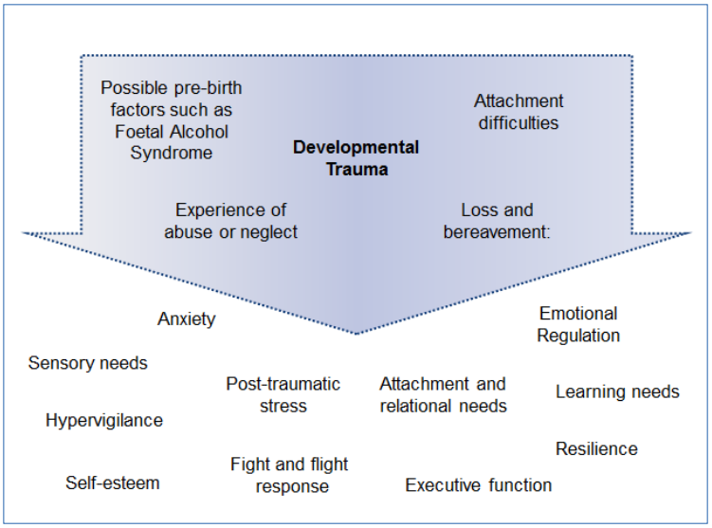

Attachment-based approaches
School staff may find that the usual behavioural approaches may have limitations with children and young people who are adopted or under special guardianship. Behaviour is communicating a message and until we show that we get the message, it is very hard to get the behaviour to stop. Children’s and young people’s behaviour may be driven by anxiety and a need to feel safe and secure.

One way of considering the importance of safety and security is through Kim Golding’s Pyramid of need that she developed to consider how to meet the therapeutic needs of traumatized children (shown below). This pyramid highlights the critical foundation of children and young people first feeling safe, both physically and emotionally, as a precursor to them develop relationships and emotional regulation.
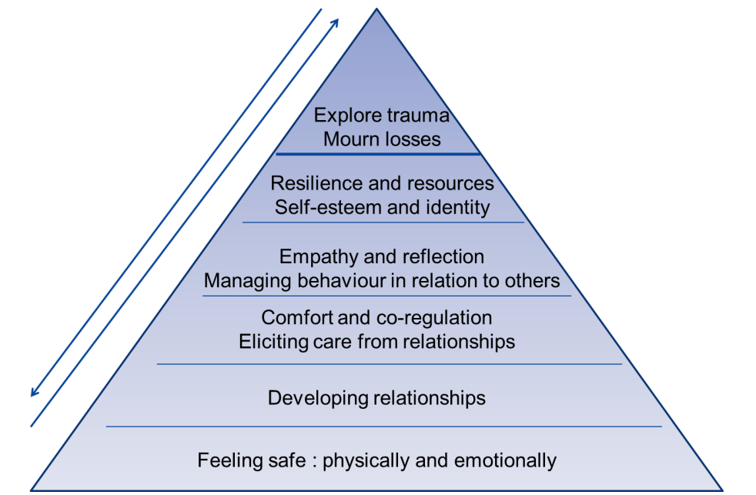

Pyramid of need Kim Golding (2015)

http://kimsgolding.co.uk/resources/models/meeting-the-therapeutic-needs-of-traumatized-children/

School staff will be supporting children and young people who are adopted or under special guardianship in partnership with parents, guardians, and potentially other multi-agency colleagues. The top level of the pyramid may be more likely to reflect conversations between the child or young person with parents, and/or professionals working in a therapeutic capacity. However, school staff can play a vital role in supporting children and young people in developing their sense of security, relationships and emotional regulation which form the vital base levels of the pyramid.

Key adult relationship
As discussed previously, it is likely to be beneficial for children and young people who are adopted or under special guardianship to have a named key adult to support them in feeling emotionally safe and to gradually develop a positive relationship that can act as a secure base or ‘key attachment figure’. In addition to emotional support from a key adult, children and young people may benefit from consideration of how to help them feel safe through consistency in terms of their environment, the structure of the school day and their routines. It will be helpful for a consideration of who the child or young person can seek support from if their key adult is out of school or unavailable. It will also be important for there to be consideration of an agreed safe space in addition to a safe person, for a child or young person to have access to if they are distressed.

Children and young people need clear boundaries to help them to feel safe and contained, with adults responding predictably and calmly to their behaviour, especially when they may be finding things hard. This model emphasises the fundamental nature of safety and relationships as the building blocks and precursor to higher level skills of reflection and emotional regulation.

Questions to consider

What support do you offer in your educational setting at each of these levels?

How might we help children and young people to move through these levels?

You are likely as a school to have a range of approaches that you use to support children and young people with developing their self-confidence, self-esteem, emotional understanding and emotional regulation. For children and young people who are adopted or under special guardianship, they are likely to need these approaches at a greater level of frequency and intensity, alongside relational support from key adults, to enable them to feel safe and secure in the school environment and as a pre-cursor for their subsequent engagement in their learning and the social context of the school.

Building relationships
One model that can be helpful in building emotional safety and developing supportive relationships is the The PACE approach as developed by Dan Hughes (2005) which seeks to include key attitudes to shape all interactions with children, both verbal and non-verbal to communicate: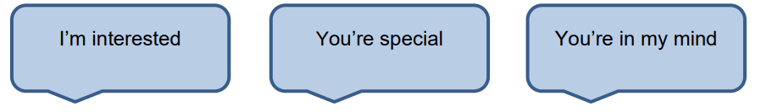
An attitude of PACE (Playfulness, Acceptance, Curiosity, Empathy) has been suggested to be very helpful to enable staff to be open and engaged with children and young people (Dan Hughes, 2009, 2012).
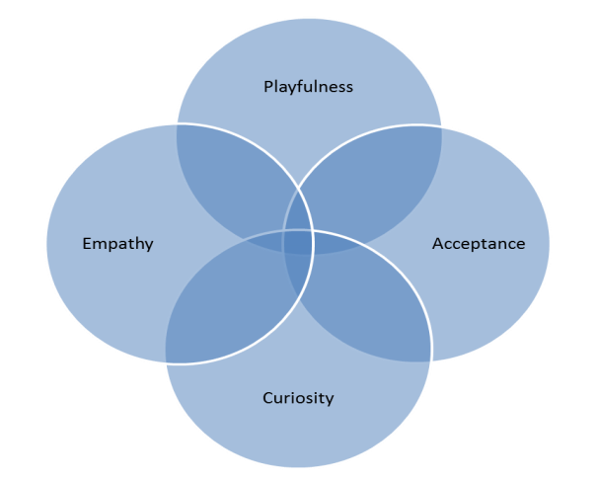

Appendices

Appendix 1 – Education Plan template
Education Plan
Previously Looked After Children
Confidential
Name
Year Group
Parent/Carer
Date of Meeting
Date of review:

PART A – Completed by parents/carers
Child’s Name:
Date of Birth:
Information completed by:
Relationship to child:
Young Person’s Views (please ensure that the young person gives their views):
My strengths are:
My interests are:
I would like to get better at:
I find it hard when:
I would like some help with:
Significant information on pre-adoptive and early adoptive experiences (what loss and trauma has the young person suffered?)
Young person’s areas of strength:
Young person’s areas of difficulty:

Part B – To be completed jointly by parents/carers, school and other professionals where appropriate
Date of Meeting:
Name of Educational Provision:
Date placed with Adoptive Family: |  |  | Age at Placement:
Parents’ Names:
Date of Admission:
Request for Additional Services: | Yes: |  |  | No: Not at this time
Is the young person identified on the SEN Code of Practice? | No: | SEN Support (K): |  |  |  | EHCP:
Parents have agreed that copies of this EPAC can be shared with:
Please list below other professionals involved:
Those attending this meeting are:
Name: | Role: | Contact Details:
Indicate where any further, or more detailed information, can be found (eg. document held by parents or in school file is available to specific members of staff)
Target areas for supporting the young person: (including any additional funding)
Aims for Support (how will you know when things have improved?)
Action Needed: (including discussion of any additional funding) |  | By when? | By whom?
Completed by:
Role:

Appendix 2 – Letter to parents/carers
Date:
Dear Parent/guardian

Re: Pupil Premium Grant for Previously Looked After Children

I am writing to discuss the Pupil Premium Grant for previously looked after children – adopted children or those with special guardianship.

The Pupil Premium Grant for 2021 to 2022 includes pupils who were looked after by an English or Welsh local authority immediately before being adopted; or who left local authority care on a Special Guardianship Order (previously known as a Residence Order)

The Grant is currently £2345 per eligible pupil and is used to give these children the additional support they need. Children who have been adopted or placed in care may often experience grief or loss. Exposure to this kind of trauma can have a lasting impact on pupils and play a significant role in their emotional development. Access to the £2345 grant will enable us to provide specific support – assisting the children educationally and helping address their wider needs.

The grant can only be spent to benefit these pupils and must be used to improve the outcomes in the following areas:

- Academic achievement and progress
- Wider achievement, e.g in an area that the child is academically more able in
- Attendance
- Inclusion, e.g reducing fixed-term exclusions
- Social skills
- Transition

We currently use the pupil premium to improve outcomes for pupils by [use this space to outline how your school currently spends the pupil premium to benefit pupils]

If your child meets the Previously Looked After criteria and the school is unaware, notifying us could help your child receive additional support that they are entitled to. [A named person here may help reassure parents/guardians] would need to receive a copy of the relevant legal order, in order for school to receive the funding.

We respect the confidentiality of the data and understand the sentstive nature of any information passed. I can assure you that we will comply with our data protection responsibilities as set out in the GDPR and the Data Protection Act 2018.
In order to keep the strictest confidentiality possible, we will accept notification in the way parent or guardian feels most comfortable; via phone on [insert school phone number], email using [insert email address for relevant person], in writing or face-to-face.

Yours sincerely,

[Name]

Appendix 3. – School based interventions

Possible school based interventions and approaches supporting attachment and relational needs:

Attachment Based Mentoring
http://www.babcock-education.co.uk/ldp/attachment-based-mentoring

Circle of Friends Intervention
http://www.antibullyingworks.co.uk/resources/intervention-strategies/circle-of-friends/

ELSA Emotional Literacy Support Assistants
http://elsanetwork.org/

Emotion Coaching
https://www.emotioncoachinguk.com/

PACE model by Dan Hughes
https://ddpnetwork.org/about-ddp/meant-pace/

Thrive
https://www.thriveapproach.com/

