**SEND Vision**

Families in Bolton will have well planned provision from birth - 25 that meets their needs and prepares them for independence through integrated services across education, health & social care working closely with parents and carers in a timely way

**Bolton 2030  
Vision**

**Active**

**Connected &**

**Prosperous**

**Children Young People**

**and Families**

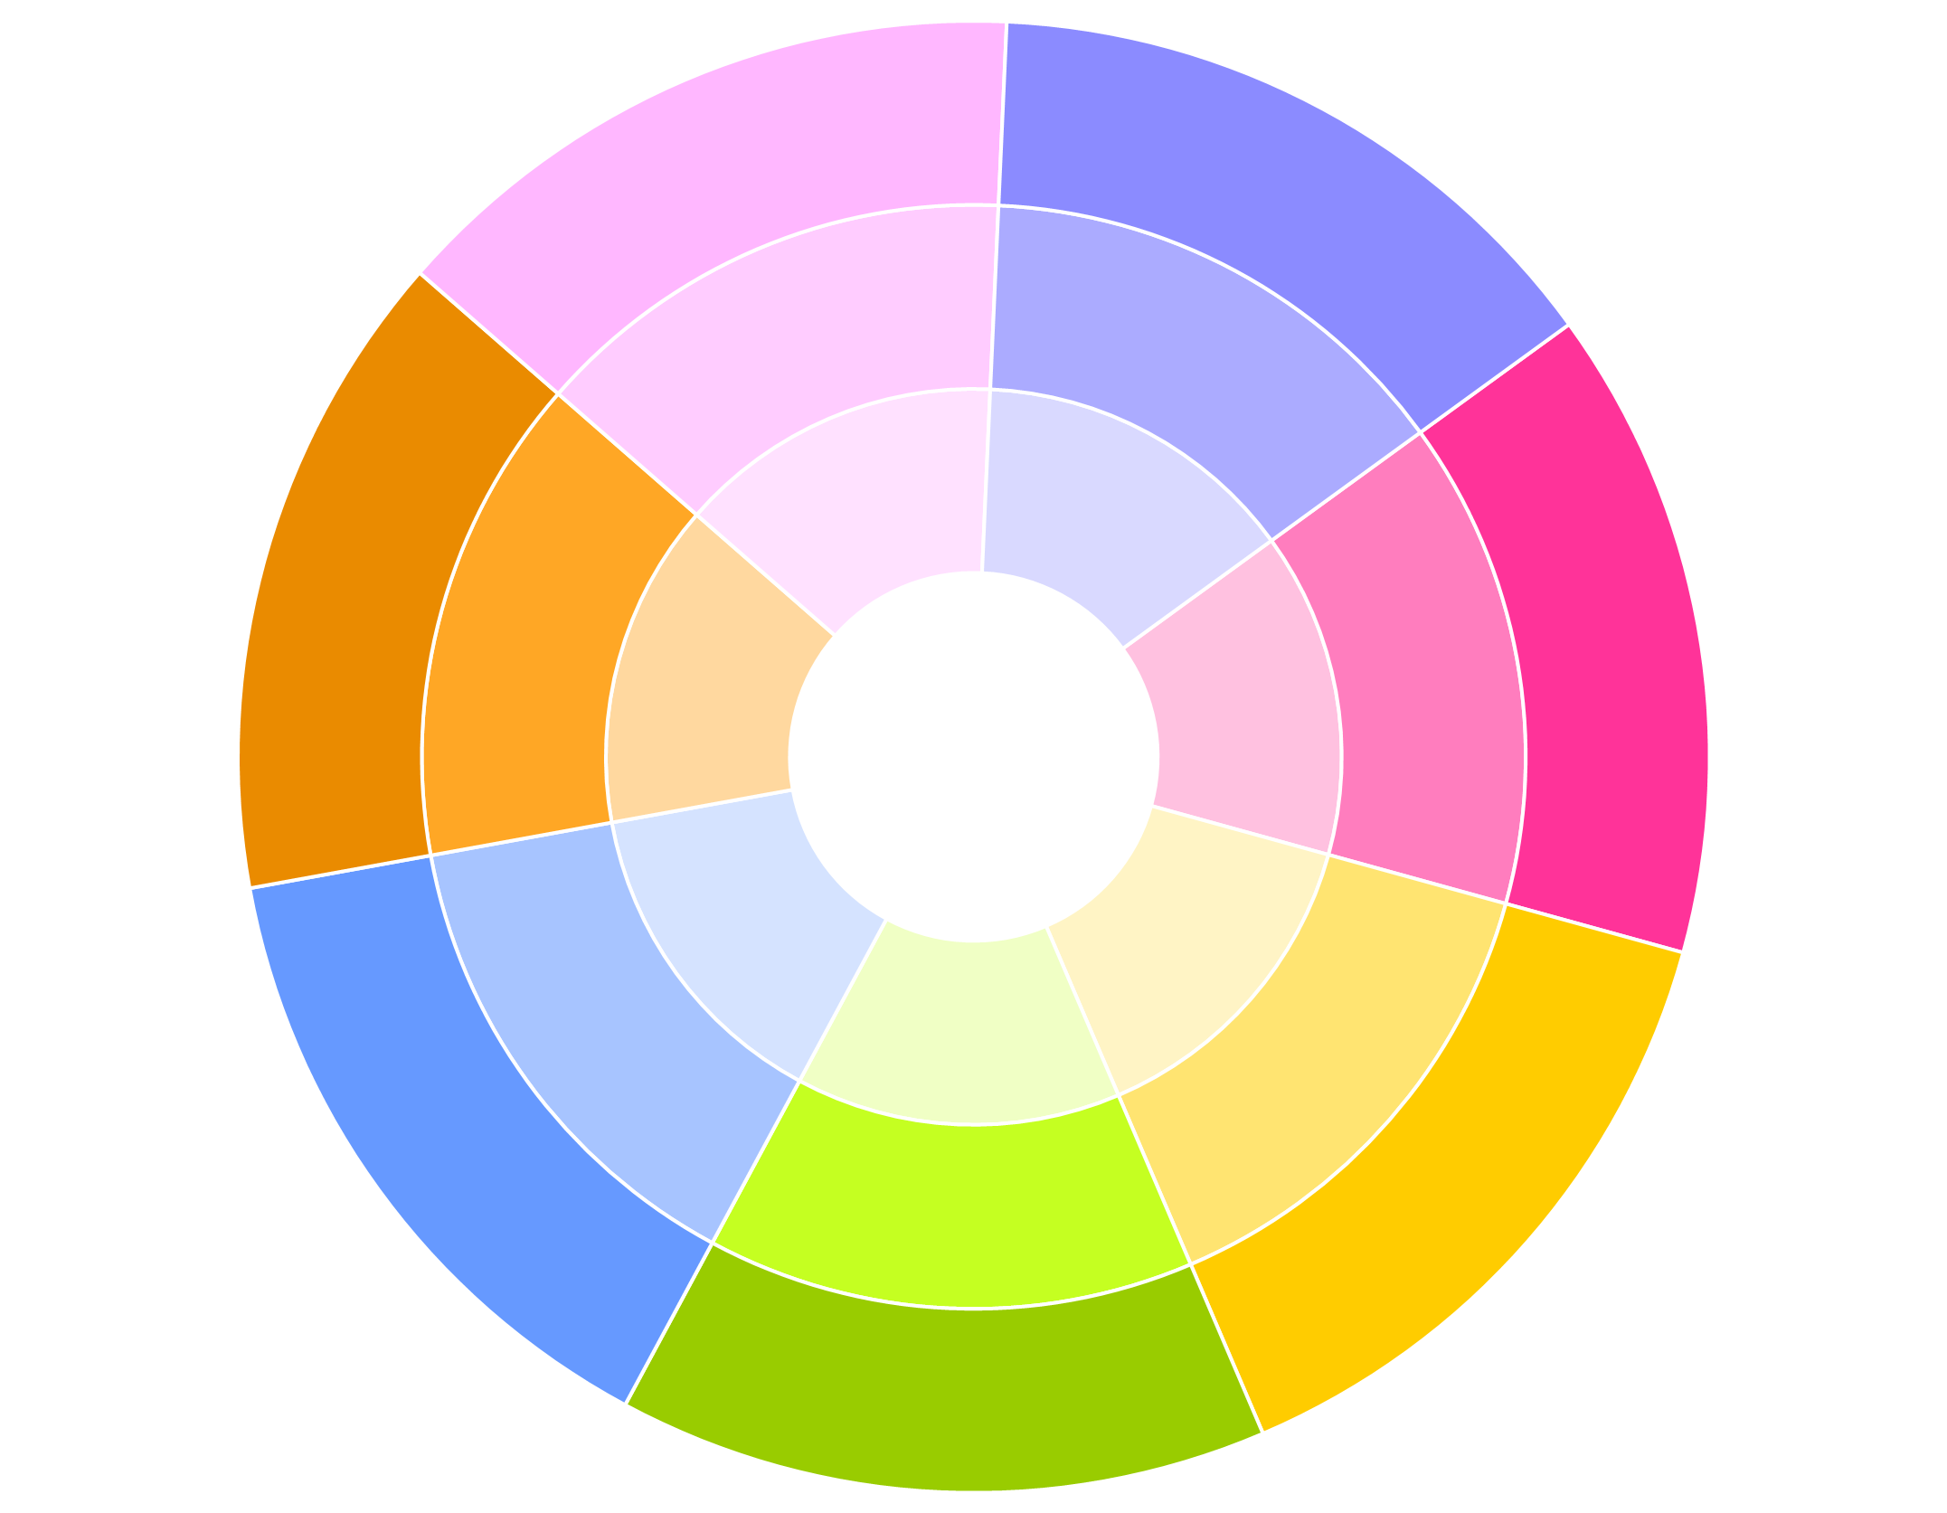

Digital Strategy

The local offer will be widely understood.

Parental confidence in the local offer,

especially at SEN support, will be high.

A revised and improved co-produced

local offer.

CYP, their families & those

working with them will have

a comprehensive relevant

and navigable local offer

that celebrates all that   
Bolton has to offer.

Involve and enable

CYP with SEND and

their families.   
(Co-production)

Interdependencies / links

with other work streams

To improve educational and

lifelong outcomes

for CYP with SEND,

especially those at   
SEN support.

Primary Exclusion Working Party

SEMH Planning Group

Early Help/Stockport

Family Model

CYP with SEND will

feel part of their local

community, included

at school and valued.

0-19 Service

Early Help Work

We will use our data to develop a

shared understanding of pressures and

individual issues with schools and parents.

SEND support services & provisions will be

quality assured, focused on improving

outcomes and targeted appropriately.

Increased local SEMH provision.

To ensure that there

are sufficient high quality,

local provisions and services

to meet demand and the needs

of the children and families

of Bolton.

**Brokerage framework**

**JSNA ENWB board**

**Personalisation & choice**

**(PB) Working Group Permanence Strategy**

**Commissioning restructure**

Governance arrangements that

facilitate & enable joint strategic planning

& commissioning across the LA and

CCG will be in place and

contribute to improved outcomes for

CYP with SEND.

Education, health &

social care will work

together to jointly

commission provisions &

services that improve

outcomes for CYP with SEND

and their families.

Transition Pilot

Permanence strategy

Autism Partnership Board

YP with SEND in Bolton will be

well prepared for adulthood.

There will be clear pathways & processes

to promote independence & facilitate the

transition from Children's to Adult services in

a timely manner. YP with SEND will report

positive experiences of transition.

Preparation for adulthood

& independence from the

earliest years.

Mainstream schools will welcome & feel equipped to meet the

needs of CYP with SEND. Parents will feel confident in the

ability of mainstream schools to meet the needs of

CYP with SEND. Good practice across mainstream

& special schools will be systematically shared.

Increased local SEMH provision.

 Bolton pupils with SEND will achieve better than,

or at least as well as, other pupils nationally

who have SEND.

Bolton pupils with SEND will be well

prepared for adulthood.

**PRIORITIES**

**DESIRED OUTCOMES**

CYP with SEND their

families will be well informed.

CYP with SEND and their families will feel

listened to and will feel part of any decision making

at both a strategic and individual level.