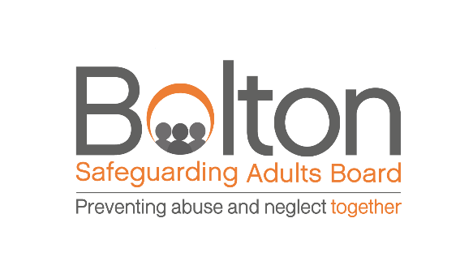
15 – 19 November 2021 - Safeguarding Adults Week

Staff Training Offer

‘Eyes Wide Open’, focusses on Domestic Abuse and Violence in Older Adults.

There will be training courses for everyone in the Bolton Partnership.
- How good are you at recognising the signs of Domestic Abuse and Violence?
- What does Domestic Abuse look like for an older person or someone with care and support needs?

Do you need to refresh your training? See what’s on offer here booking details below;

Please be aware that there are limited places available so booking early is advisable.

Monday 15 November
-Virtual Training – Bolton at Home – various times (professionals will need to email their names and roles to peopledevelopment@boltonathome.org.uk)

-Evergreen Training for Endeavour 13:00 – 14:30 Register here!

Tuesday 16 November
-Virtual Training – Bolton at Home – various times (professionals will need to email their names and roles to peopledevelopment@boltonathome.org.uk)

Wednesday 17 November
-Virtual Training – Bolton at Home – various times (professionals will need to email their names and roles to peopledevelopment@boltonathome.org.uk)

-Evergreen Training for Endeavour 13:00 – 14:30 Join here!
(Meeting ID: 861 5829 3406, Passcode: 470352)

-Survivor Story Session hosted by Fortalice at The Hub, Bolton CVS - 12:30 – 13:30 (limited places, invitation only)

-Safeguarding Adults at Risk 14:00 – 16:30 this is specifically for the VCSE sector and you can register here.

Thursday 18 November
-Virtual Training - Bolton at Home – various times (professionals will need to email their names and roles to peopledevelopment@boltonathome.org.uk)

Friday 19 November
-Virtual Training - Bolton at Home – various times (professionals will need to email their names and roles to peopledevelopment@boltonathome.org.uk)

-Survivor Story Session by Fortalice - 12:30 – 13:30 at the Octagon Theatre (limited places, invitation only)

