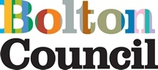
Street Art Commission: Bolton Town Centre
Artist Brief- August 2026

Introduction
Bolton Council is seeking to commission up to three professional street artists or graffiti artists to create large-scale murals at key locations across Bolton Town Centre:
- Dawes Street Skatepark
- Newport Street Arcade
- Back Cheapside
The commissions aim to transform these sites through high-quality public artwork that celebrates Bolton's identity, heritage and future aspirations. The murals should contribute positively to the town centre environment, create visual interest, and encourage greater pride in place among residents and visitors.
Artists may apply for one or more locations. The project will be delivered from September 2026 onwards. Applicants should provide a detailed budget for their chosen site(s) in application, Bolton Council will cover any plant hire costs.

Commission Objectives
The commissioned artworks should meet the following objectives:
- Enhance the appearance and character of the selected sites.
- Reflect Bolton's unique identity, history, communities and future ambitions.
- Create vibrant, welcoming and memorable public spaces.
- Celebrate the town's creativity, culture and sense of place.
- Be informed by engagement with key stakeholders, including users of Dawes Street Skatepark where relevant.
- Demonstrate artistic excellence and suitability for a public environment.

Artist Responsibilities and Outputs
The commissioned artist(s) will be responsible for:
1. Research and Development
Working with Bolton Council and relevant stakeholders to develop an appropriate artistic approach, theme and style for the site.
2. Community Engagement
Undertaking conversations and consultation activities with relevant stakeholders, including skatepark users where applicable, to explore ideas and themes connected to Bolton's history, identity and local character.
3. Design Development
Producing concept designs, sketches and visualisations demonstrating how the proposed artwork will respond to the chosen location.
4. Delivery
Producing and installing the final mural to an agreed specification, timescale and standard. Provide a method statement and risk assessment.

Budget
Applicants should submit a detailed budget for each location they wish to be considered for, including:
- Artist fees
- Meetings with commissioners and project partners
- Site visits
- Community consultation and engagement activities
- Design and development work
- Production and installation of the mural
- Materials and consumables
- Equipment hires and access requirements
- Travel and any other associated project costs

Submission Requirements
Artists should submit an Expression of Interest of no more than two sides of A4 to CreativeBolton@bolton.gov.uk with the subject 'Application: Street Art Commission’, including:
- Project Proposal
- A brief description of the proposed concept and creative approach.
- An explanation of how the proposal responds to the aims of this brief.

- Visual Materials
- Initial sketches, reference images, mock-ups or examples illustrating the proposed artistic style and vision.

- Artist Information
- An up-to-date CV demonstrating relevant skills, experience and previous commissions (Please note this is included in the 2-page limit).

- Budget
- A cost breakdown including artist fees, materials, equipment, production costs and any other expenses.

- Previous Work
- Examples of relevant completed projects.
- Contact details for at least two referees from previous commissions.

Selection Process
Proposals will be assessed by a panel comprising representatives from Bolton Council, community stakeholders and individuals with expertise in visual arts and public realm projects.
Applications will be evaluated against the following criteria:
- Demonstrated skills, experience and capacity to deliver the commission. (20%)
- Artistic quality and originality of the proposed approach. (40%)
- Relevance and responsiveness to the brief. (10%)
- Ability to create artwork that enhances and animates the selected location. (20%)
- Cost (10%)

Submission Details
Please submit your proposals to:
CreativeBolton@bolton.gov.uk
All required documents should be attached to a single email where possible.

Key Dates
Deadline for submissions: Sunday 27 September 2026
Assessment and shortlisting: Week commencing 28 September 2026
Applicants may be contacted during this period to clarify aspects of their proposal or provide additional information.
Please note that due to the anticipated volume of applications, only limited feedback will be provided to unsuccessful applicants.

Bolton Council welcomes applications from artists of all backgrounds and encourages proposals that reflect the diversity, creativity and character of Bolton and its communities.

Locations

- Newport Street Arcade
Pinned location: https://maps.app.goo.gl/aKaFXrwT2tZmxE6x9
Left and Right walls on the uncovered section of the walkthrough
Measurements and image below:
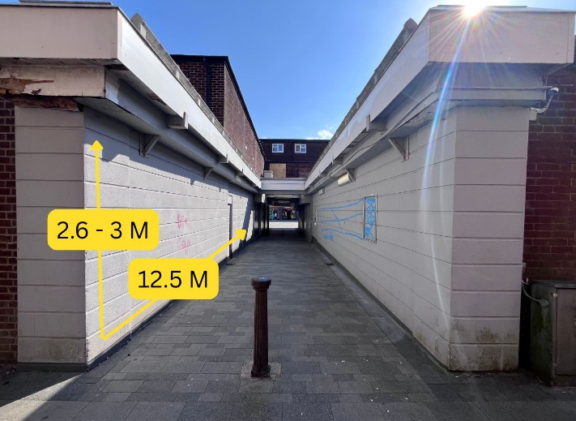

- Back Cheapside
Pinned location: https://maps.app.goo.gl/WGzXDhq48zm7T4pT8
Side wall of building. There is an external chimney stack, satellite dish and air conditioning unit which will have to remain
Measurements and image below
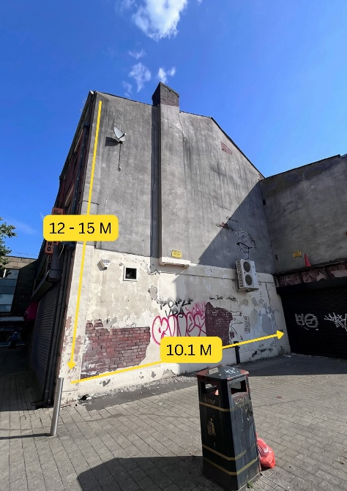

- Dawes Street Skate Park
Pinned location: https://maps.app.goo.gl/fvXzjnk1ExkhLxSq8
3 sections of wall space which are separated by brick piers
Measurements and images below:
