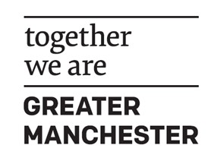
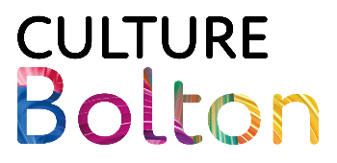

Creative Heath Working in Partnership – Brief
Grant Overview
Culture Bolton is offering grants to support a partnership approach to Creative Health for cultural organisations based in Bolton.
- 2 x Grants up to £10,000 each
- Constituted organisations only as the accountable body
- Application deadline: 5pm, Friday 10 July 2026

This fund is designed to help organisations work in partnership with other organisations (or individual artists) but a constituted organisation will need to be the accountable body.
What the Grant can support
The grant is intended to support partnership activity so any plans must include joined up working and a collaborative approach to Creative Health.
How We Define Culture in Bolton
We consider culture to include (but not be limited to):
- Art
- Music
- Literature
- Heritage
- Dance
- Theatre
- Craft
- Photography
- Film
- Design
- Museums
- Libraries
- Combined Arts

Projects should align with Bolton’s Cultural Strategy
Who Can Apply:
To be eligible for this funding, applicants must:
- Deliver activities or projects within the Bolton area.
- Work in partnership with at least one constituted organisation (who can act as the accountable body).
- Operate within Bolton’s cultural sector.
- Demonstrate clear alignment with the objectives of Bolton’s Cultural Strategy.
- Be able to complete the proposed project by 31 March 2027.
- Commit to providing all required monitoring information, evaluation, and reporting as specified by the funders.
All funded activity must make a clear and demonstrable contribution to Bolton’s cultural ecosystem.

What We Are Looking For
We welcome high-quality, creative proposals that clearly articulate how the partnership intends to use the grant funding. Applications should address the following:
- Organisational context
A concise overview of the current position of each partner, including key strengths, challenges, and any relevant external factors.
- Rationale for partnership
An explanation of why this partnership is valuable, including the specific gap, need, or opportunity that the collaboration seeks to address.
- Contribution to Creative Health in Bolton
A clear description of the proposed activity, including what it will involve, how it will support Creative Health outcomes, and the number and type of beneficiaries.
- Outcomes and longer-term impact
The anticipated changes resulting from the project, including both immediate outcomes and longer-term benefits for the partner organisations and the wider Creative Health landscape in Bolton.
- Budget and value for money
A detailed cost breakdown outlining how the grant funding will be allocated.

Assessment Criteria
All applications will be assessed based on:
- Creativity (50%)
- Link to Cultural Strategy (30%)
- Value for money (20%)

Closing Date: Friday 10 July 2026
All submissions via email to: creativebolton@bolton.gov.uk

