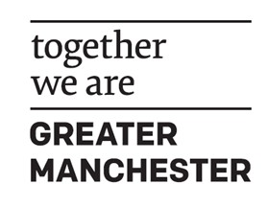
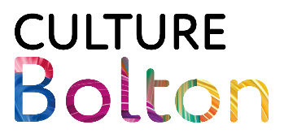

Culture Bolton – Micro Grants 2026
About Micro Grants Programme
Culture Bolton’s Micro Grants Programme supports individuals, organisations, and voluntary groups to create and deliver cultural activity across Bolton.
Grants may be used to support:
- New creative work
- Equipment
- Training
- Resources
- CPD
- Travel
- Childcare
To be eligible, applicants must live in Bolton.
All funded projects must support Bolton’s Cultural Strategy.

Bolton’s Cultural Vision: A Cultural Renaissance
We want culture to be the heartbeat of Bolton, we want it to cut through everything that we do because we believe that culture characterises us as people, links us to a place, and connects us in a community. It provides inspiration and entertainment. It is the context for interaction and cohesion. As we seek to build a strong and distinctive Bolton, our culture will define us and binds us together. It is a shared vision, and we will all benefit from its success.

How We Define Culture in Bolton
We consider culture to include (but not be limited to):
- Art
- Music
- Literature
- Heritage
- Dance
- Theatre
- Craft
- Photography
- Film
- Design
- Museums
- Libraries
- Combined Arts
Bolton’s Cultural Strategy – Priority Areas
Applications should align with one or more of the following priorities:
- Programmes and Partnerships
- Place and Space
- Young People and Emerging Talent
- Stakeholders and Resources
- Advocacy and Inclusion
- Health and Wellbeing
[You can find Bolton’s Cultural Strategy here – Bolton's Cultural Strategy]

Grant Amount
Applicants are encouraged to apply for the amount that best supports their needs, helping us fund as many creative projects as possible.
- Up to £500
- For individual creative practitioners, informal groups, and organisations
- Application deadline 12:00 noon, Monday 14 December 2026. Please note: Applications may close early if the programme becomes over-subscribed.

Application Form
1. Contact Details
- Name*
- Organisation Name* (if applicable)
- Phone Number*
- Email Address*

2. Grant Information
- What do you want the funding for?*
Include what you will do, how it will work, and who it is for.
- What are the expected outcomes?*
Explain what difference the funding will make for you, participants, audiences, or the wider community.
- How would your application support Bolton’s Cultural Strategy?*
Please refer to the priorities listed above.
- When will the activity take place?*
Funds must be used between July 2026 and February 2027.

3. Funding Request
- Total amount requested (Up to £500):*
- Budget breakdown*
Please provide a clear breakdown of how the funding will be spent

4. Participants and Audiences
If applicable please answer the following:
- How many people do you expect to participate or attend?*
- Age range of participants (please tick all that apply):
☐ All ages
☐ Under 16
☐ Mainly 16–55
☐ Mainly over 55
- Is your application targeted at any of the following groups? (tick all that apply):
☐ Young People
☐ Ethnically Diverse Communities
☐ LGBTQIA+
☐ Disabled People

5. Partnership Working
We welcome partnership projects. One organisation must act as the accountable body.
- Are any other organisations involved?
If yes, please briefly describe the partners involved and their role(s).

Thank you for your application.

