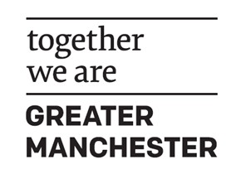
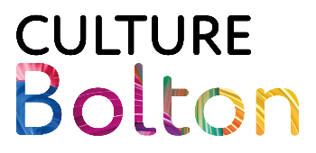

Capacity Building and Governance Grant – Brief
Grant Overview
Culture Bolton is offering two grants of up to £10,000 to support capacity building, governance development, and business planning for cultural organisations based in Bolton.
This fund is designed to help organisations strengthen their organisational foundations, improve sustainability, and position themselves for future growth and impact.
What the Grant can support
Funding may be used for activity such as (but not limited to):
- Strengthening organisational governance and leadership
- Capacity building and skills development
- Business planning and organisational development
- Strategic planning, policies, and systems
- Independent review or specialist support to support organisational growth
The grant is intended to support developmental activity, rather than delivery of new cultural programmes.
What the Grant cannot support
Funding cannot be used for:
- Building organisational reserves
- Paying off existing debts or liabilities
- Retrospective costs

Who Can Apply
To be eligible, organisations must:
- Deliver work/activity in Bolton
- Be operating within Bolton’s cultural sector
- Demonstrate how their work supports Bolton’s Cultural Strategy
All funded activity must clearly contribute to Bolton’s cultural ecosystem.

How We Define Culture in Bolton
Culture in Bolton includes (but is not limited to):
- Art
- Music
- Literature
- Heritage
- Dance
- Theatre
- Craft
- Photography
- Film
- Design
- Museums
- Libraries
- Combined arts
Alignment with Bolton’s Cultural Strategy
Applications should align with one or more of the following priority areas:
- Programmes and Partnerships
- Place and Space
- Young People and Emerging Talent
- Stakeholders and Resources
- Advocacy and Inclusion
- Health and Wellbeing

What We’re Looking For
We invite proposals that clearly outline how your organisation would use this grant. Your proposal should address:
- Current organisational position and context — a concise overview of where your organisation is now, including strengths, pressures, and any relevant external factors.
- The challenge or need the grant will address — the specific organisational gap, risk, or opportunity you aim to tackle.
- How the proposed activity will build capacity or strengthen governance — the practical steps you will take and why they matter for your organisation’s development.
- Expected outcomes and longer-term benefits — what will change as a result of this investment, both for your organisation and for Bolton’s wider cultural sector.
- A full cost breakdown — a clear explanation of how the grant funding will be allocated.
All proposals will be assessed using a weighting of 70% quality and 30% value for money.
Important Note
This is a conversation-led fund. We encourage prospective applicants to talk to us before submitting a proposal to explore suitability, refine ideas, and understand how the grant can best support their organisation.

Get in touch: Creative.Bolton@bolton.gov.uk

